Supplementary Data 2:
Information on the enzymes involved in biosynthesis of selected secondary metabolites. Each metabolite contains data for the pathway, multiple sequence alignment (MSA) with FIRs marked in them and the phylogenetic tree including the closely related protein sequences.
- Alkaloids:
  - Glycine betaine:
    - Pathway: We identified two enzymes in fenugreek, viz. choline monooxygenase (CHMO) (EC: 1.14.15.7) and betaine aldehyde dehydrogenase (BADH) (EC: 1.2.1.8)
(Pathway adapted from Plant Metabolics Network (PMN), https://pmn.plantcyc.org/PLANT/NEW-IMAGE?type=PATHWAY&object=PWY1F-353&detail-level=3, on www.plantcyc.org, Aug 12, 2021¹)

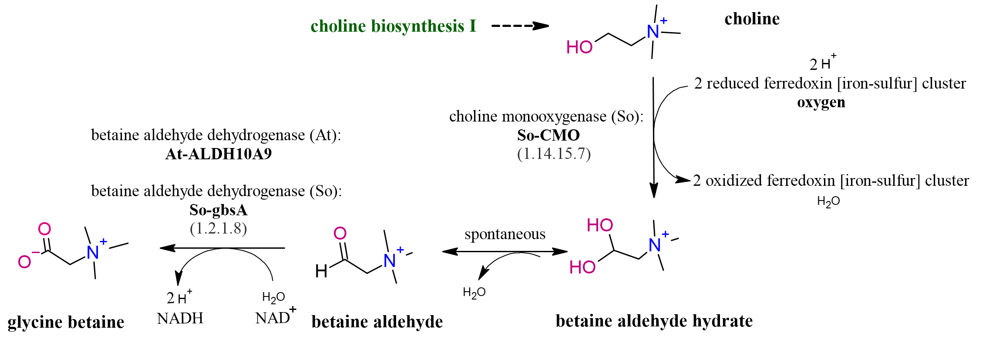

    - MSA with FIRs:
i) CHMO hit in fenugreek (Tfoe_c38951_g1_i2_m30577) is marked in the MSA along with the two FIRs.
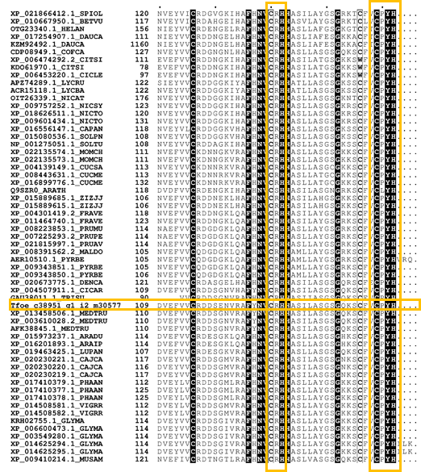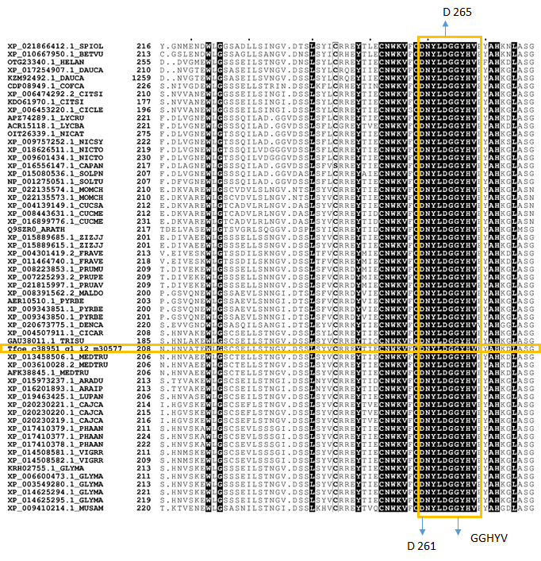
ii) BDH hit in fenugreek (Tfoe_c38951_g1_i2_m30577) is marked in the MSA along with the three FIRs.
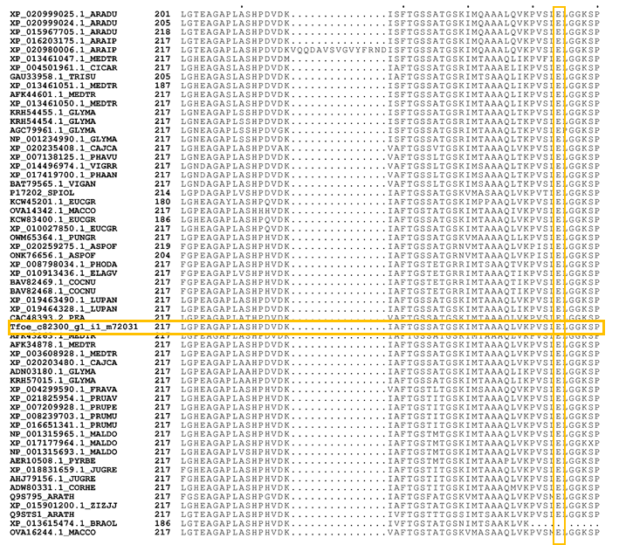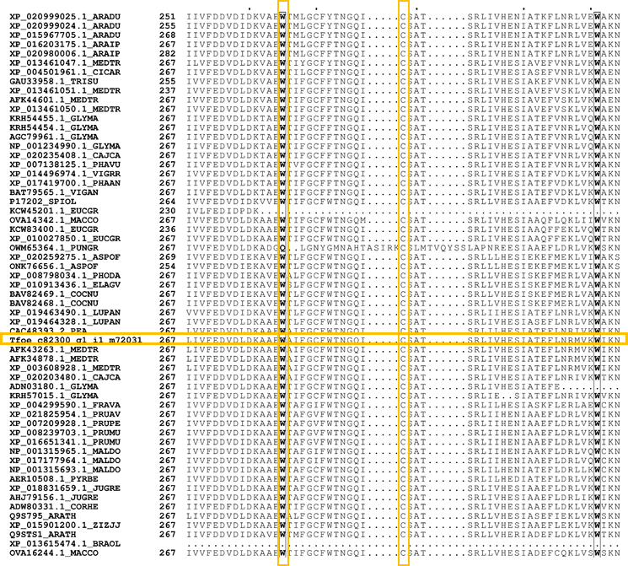
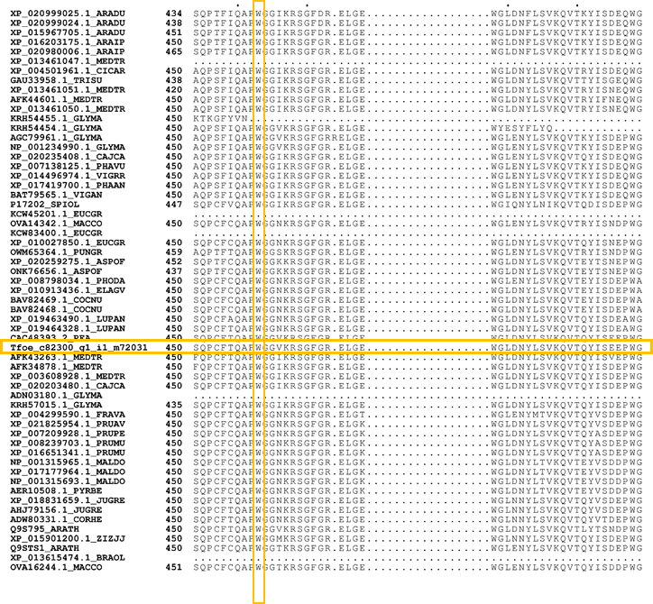
    - Phylogenetic tree:
- CHMO hit in fenugreek highlighted (Tfoe_c38951_g1_i2_m30577) co-clustering with the M.truncatula protein (XP013458506.1_MEDTR).
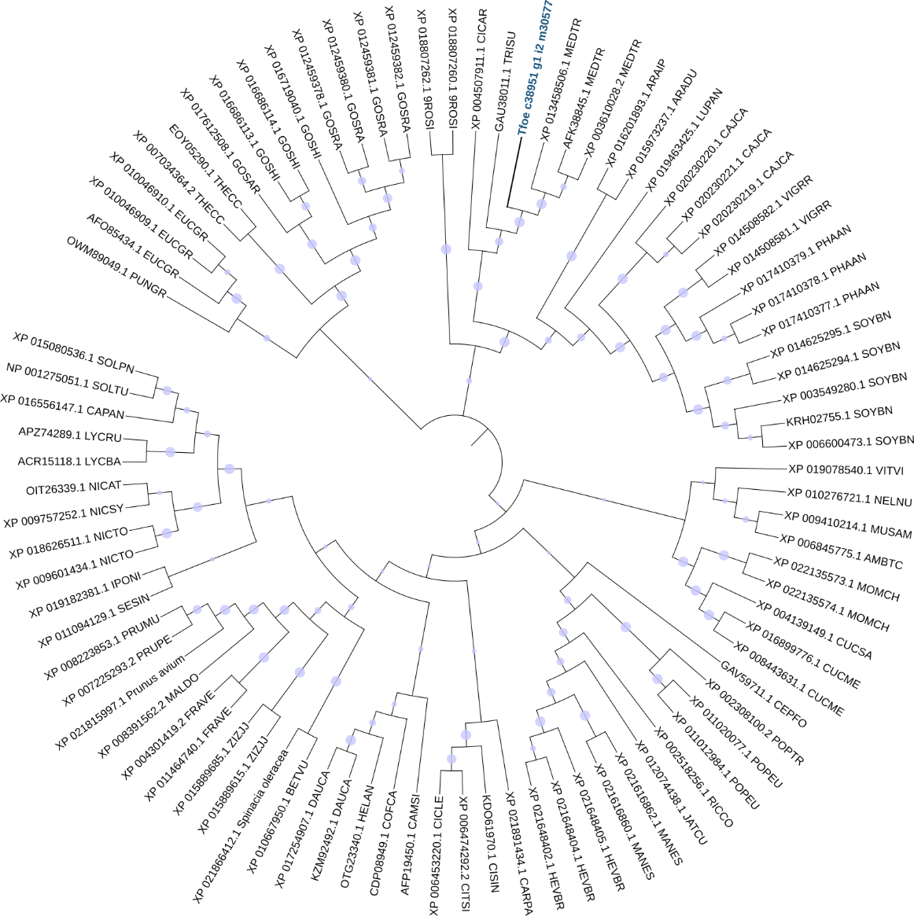
- BADH hit in fenugreek is highlighted (Tfoe_c82300_g1_i1_m72031) co-clustering with the M.truncatula protein (AFK43263.1 MEDTRU).
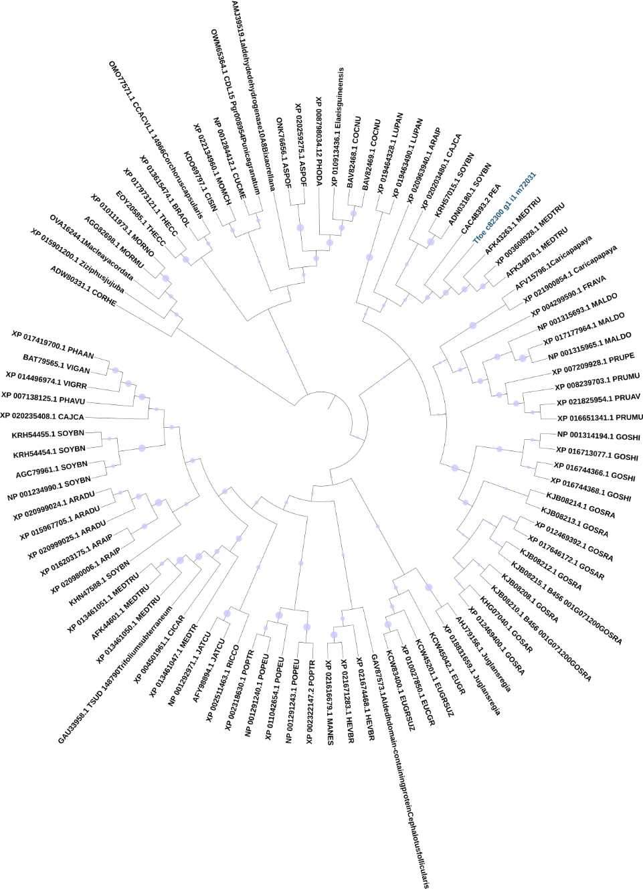

- Saponin (diosgenin):
2.1. Pathway (adapted from Ciura et al., Planta, 2017²):
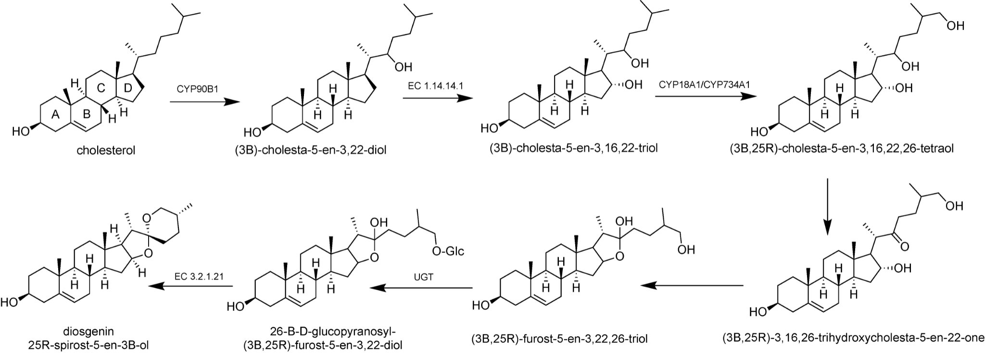

2.2. Sterol-3β-glucosyltransferase ((A)PSBD motif, (B) PSPG motif and (C) phylogeny of hits from fenugreek with sterol-3β-glucosyltransferase sequences from other plants)
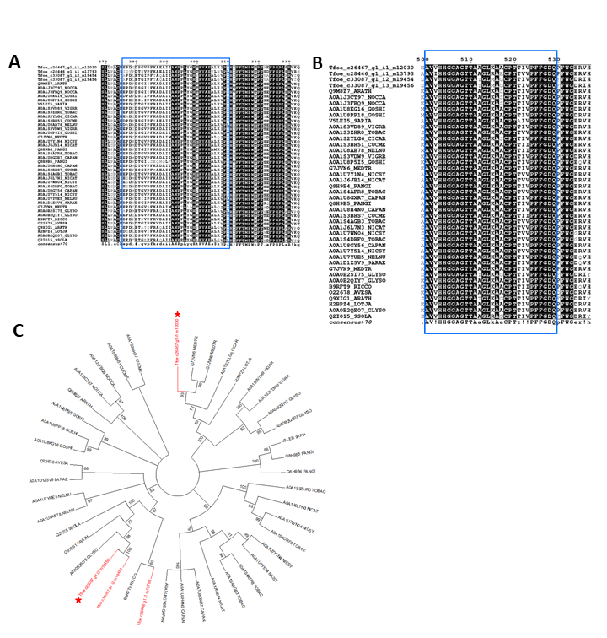

2.3. β-glucosidase enzyme ((A)TENG motif, (B) TFNEP motif and (C) phylogeny of hits from fenugreek with β-glucosidase sequences from other plants)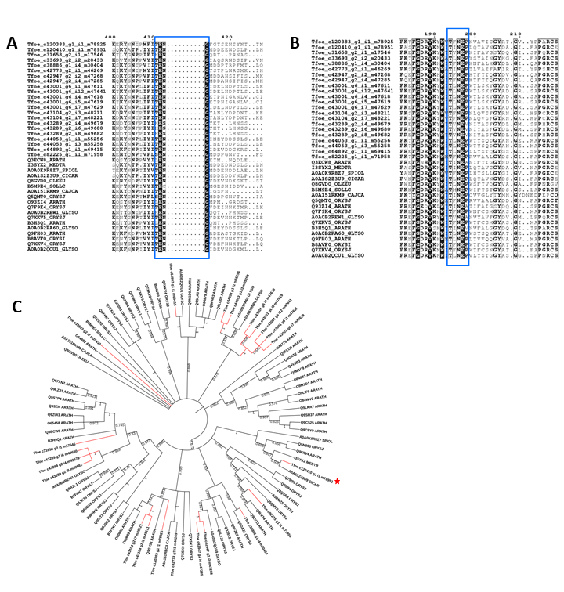

- Volatiles:
- Eugenol
- Pathway (Adapted from Plant Metabolics Network (PMN), https://pmn.plantcyc.org/PLANT/NEW-IMAGE?type=PATHWAY&object=PWY-5859&detail-level=3, on www.plantcyc.org, Aug 12, 2021¹)
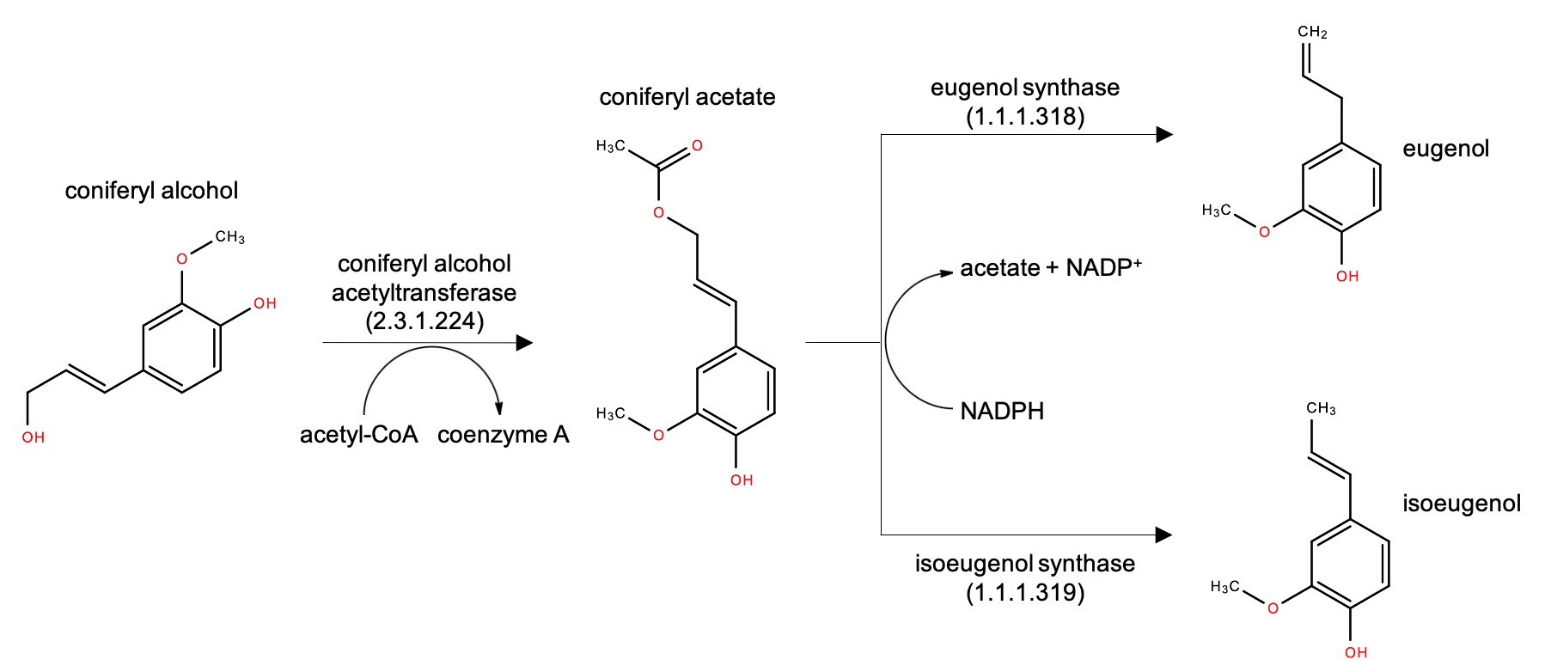
- MSA with FIRs
i. Coniferyl alcohol acetyltransferase hit in fenugreek (Tfoe_c37673_g1_i1_m27189 and Tfoe_c102741_g1_i1_m76275) are marked in the MSA along with the two FIRs. Only Tfoe_c37673_g1_i1_m27189 maps correctly for both the FIRs.
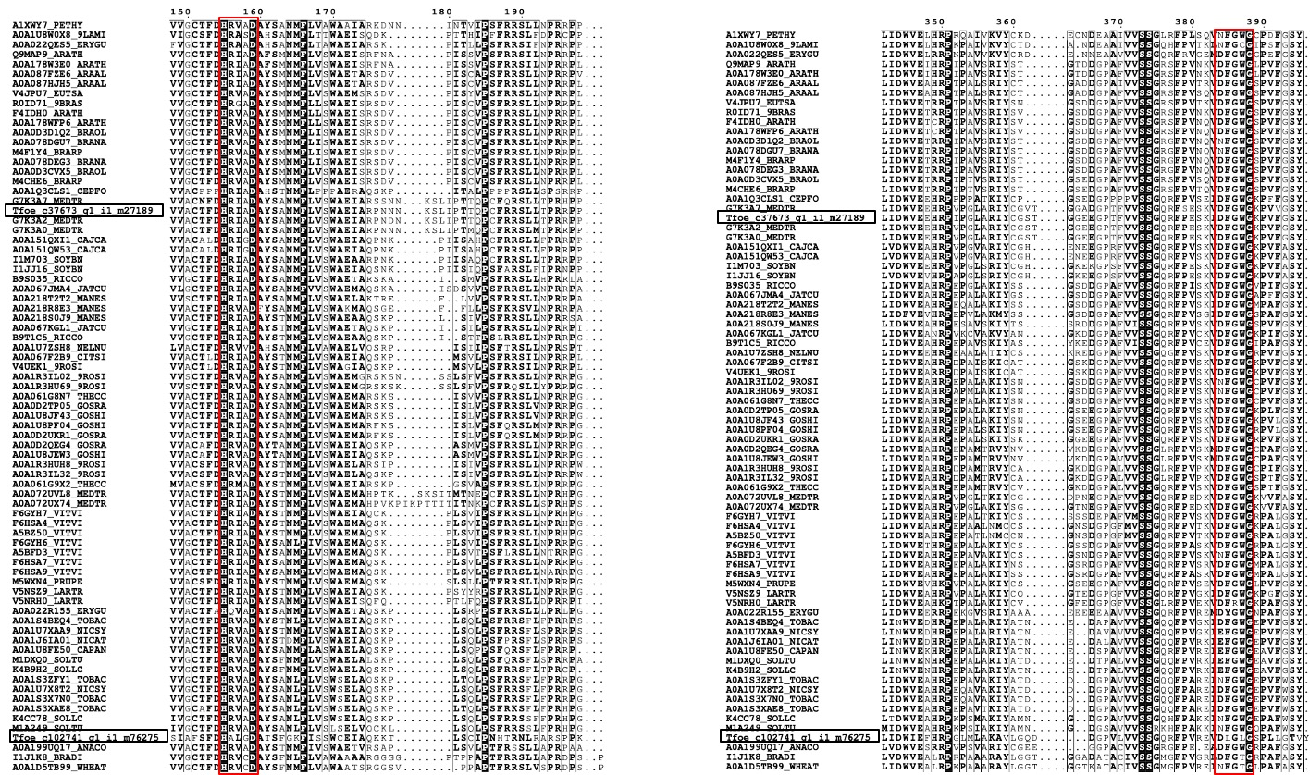

ii. Eugenol synthase and isoeugenol synthase hits in fenugreek are marked in the MSA along with the FIR.
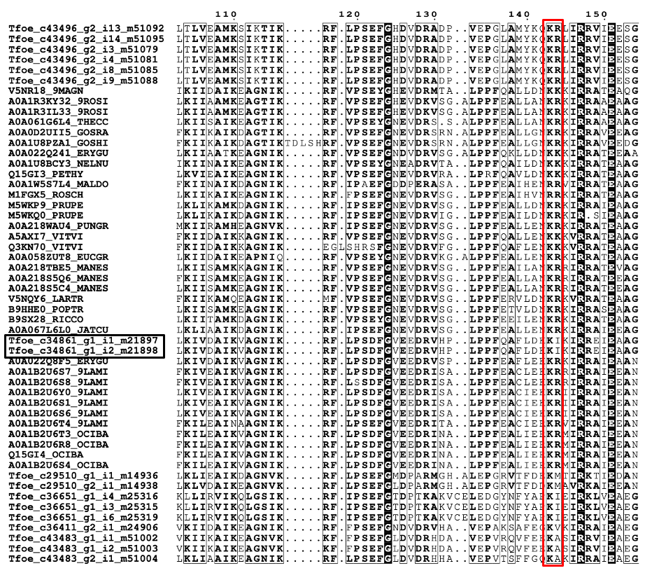

- Phylogenetic tree
- Coniferyl alcohol acetyltransferase hits in fenugreek (Tfoe_c37673_g1_i1_m27189 and Tfoe_c102741_g1_i1_m76275) are marked, however, Tfoe_c37673_g1_i1_m27189 co-clusters with the M.truncatula protein (G7K3A2 MEDTR) is considered as the true hit.
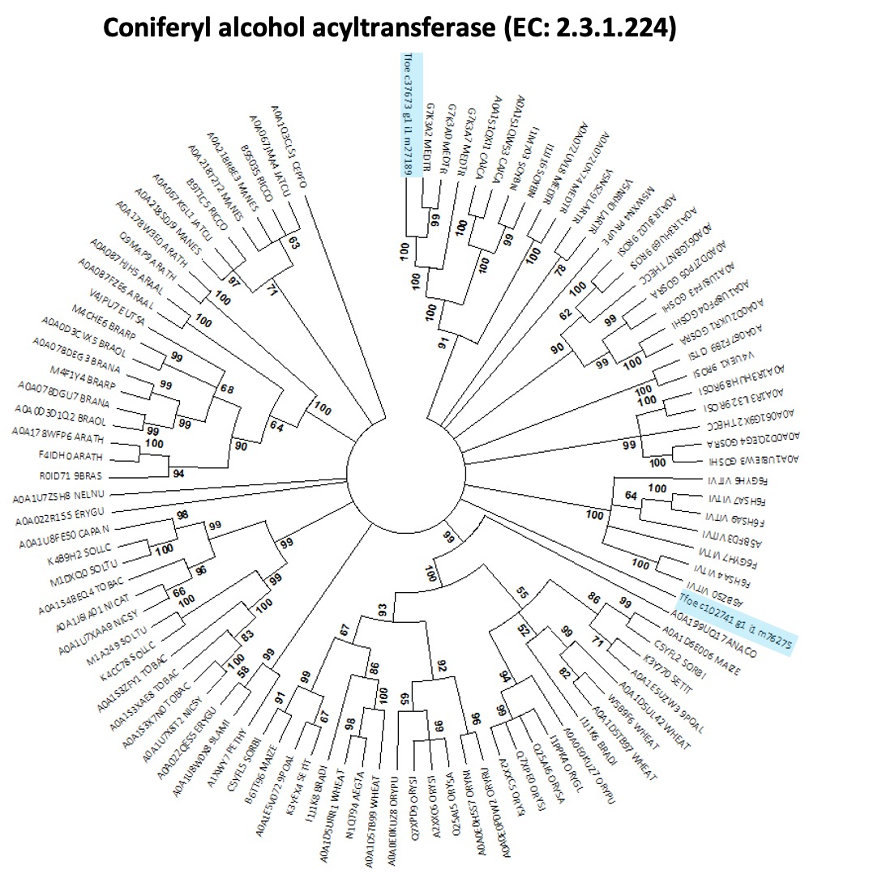

ii. Among the several hits, fenugreek proteins co-clustering with the closely related plants for eugenol synthase and isoeugenol synthase were selected as true hits.
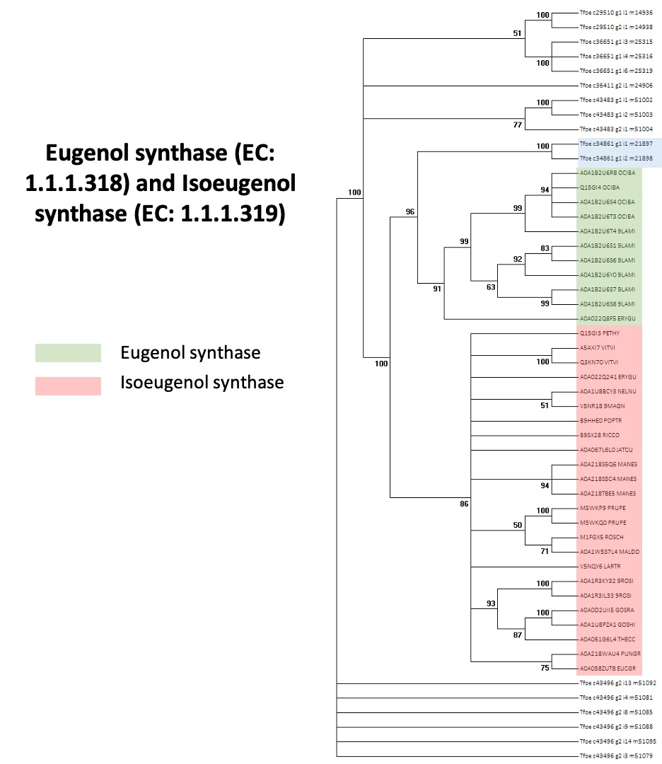

- Linalool
- Pathway (Plant Metabolics Network (PMN), https://pmn.plantcyc.org/PLANT/NEW-IMAGE?type=PATHWAY&object=PWY2OL-4&detail-level=3, on www.plantcyc.org, Aug 12, 2021¹)
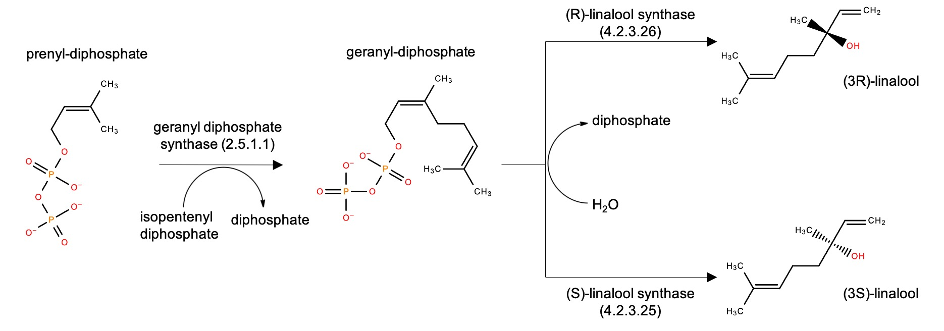

- MSA with FIRs
i. Farnesyl-pyrophosphate synthase hit from fenugreek (Tfoe_c5299_g1_i1_m1972) and the mapped FIRs are mapped in the MSA
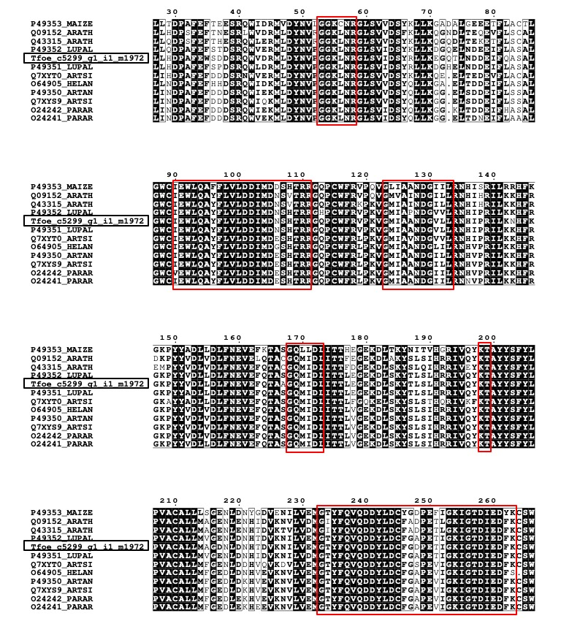

ii. (3S)-linalool synthase hits (Tfoe_c11093_g1_i1_m4195, Tfoe_c11093_g1_i2_m4196) and (3R)-linalool synthase hits (Tfoe_c44084_g4_i2_m55446) from fenugreek are marked with other fenugreek hits and other plant sequences. The two FIRs are marked as blocks in the MSA.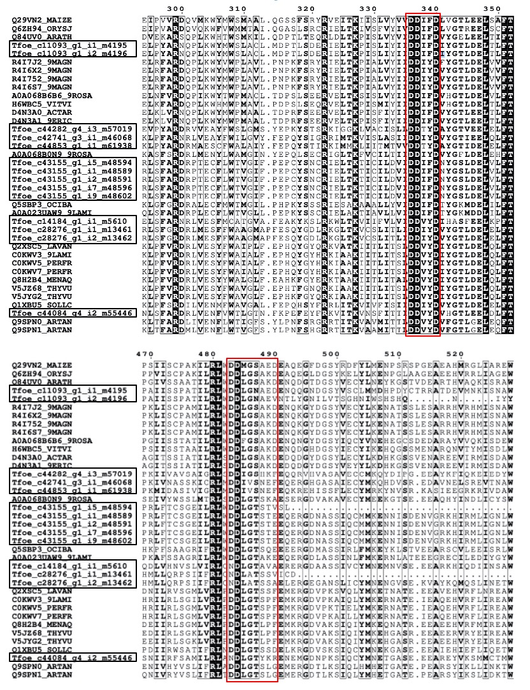
- Phylogenetic tree
i. Farnesyl-pyrophosphate synthase hit from fenugreek (Tfoe_c5299_g1_i1_m1972) co-clustered with Lupinus albus (Fabaceae family) proteins as highlighted.
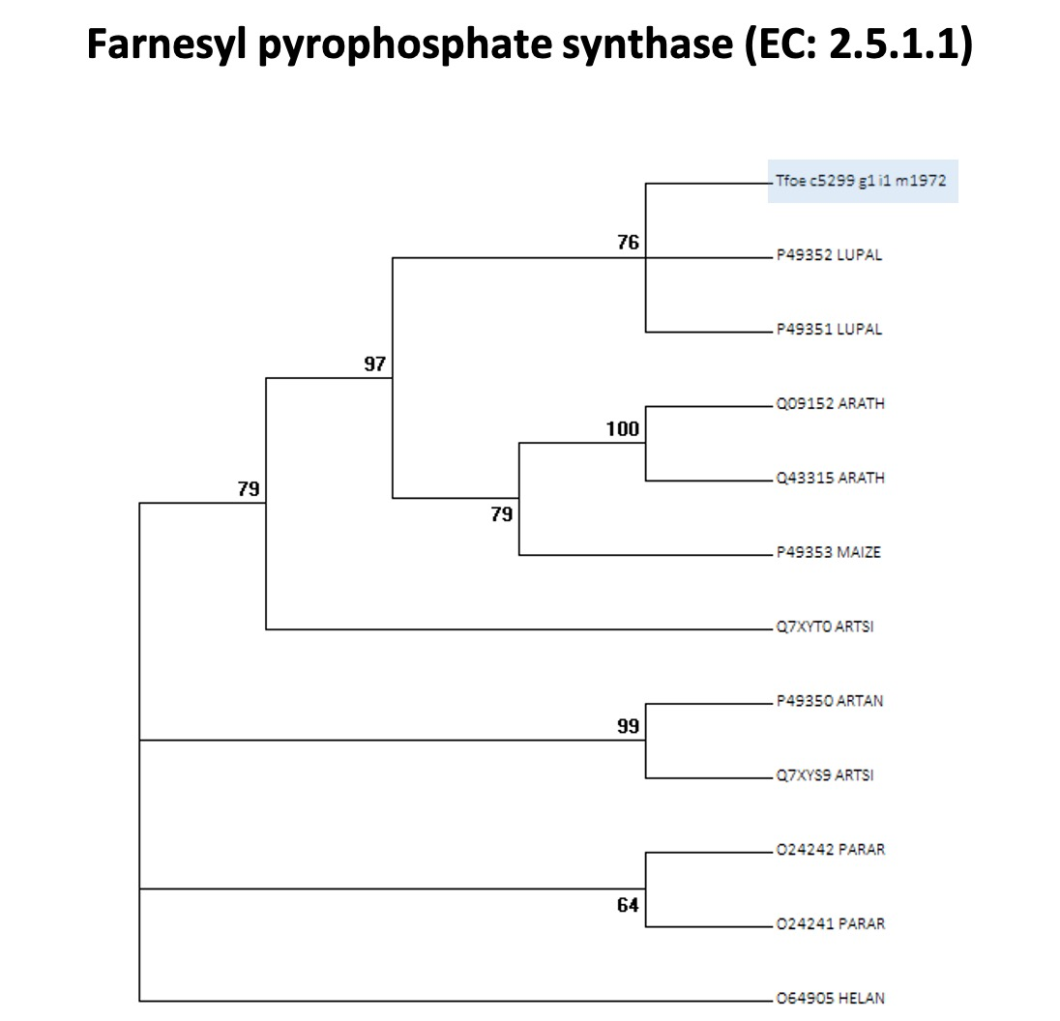

ii. (3S)-linalool synthase hits (Tfoe_c11093_g1_i1_m4195, Tfoe_c11093_g1_i2_m4196) are highlighted in blue and co-clustering with sequences from other plants (highlighted in green). (3R)-linalool synthase hits (Tfoe_c44084_g4_i2_m55446) co-clusters with other plant sequences (highlighted in red).
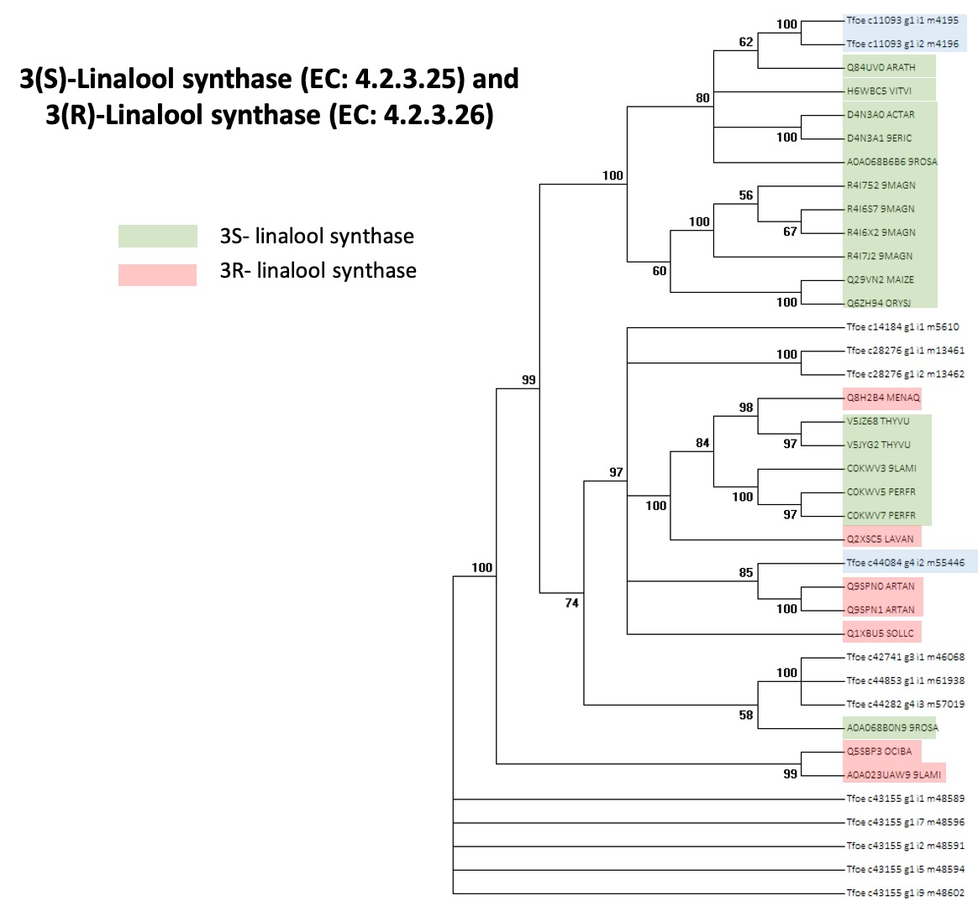

- Flavonoids:
- Quercetin
- Pathway (Adapted from Pasha N, et al, Genomics, 2019³)
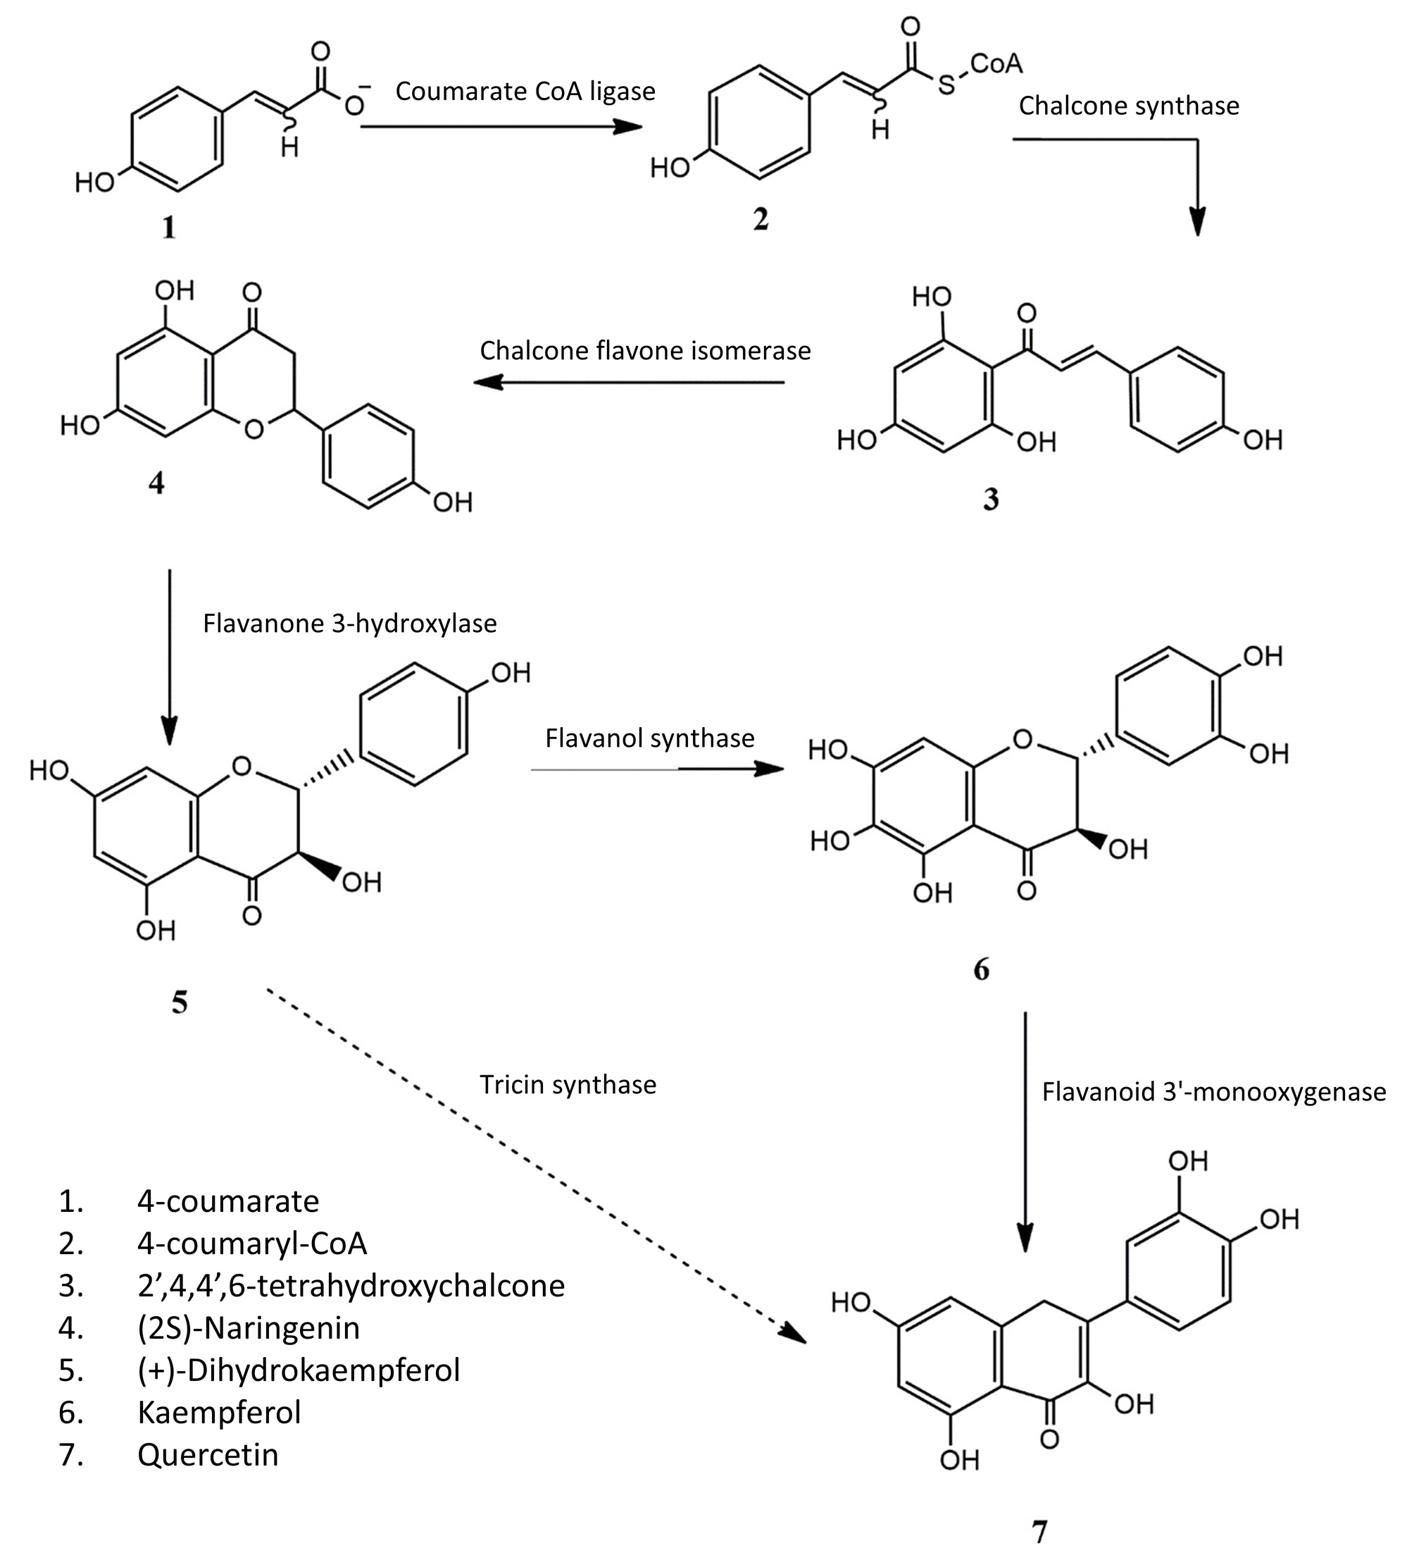

- MSA with FIRs: Multiple hits were observed for the enzymes of quercetin biosynthesis pathway. The fenugreek hits and FIRs are marked for each enzyme in their MSAs.
i. Coumarate CoA ligase
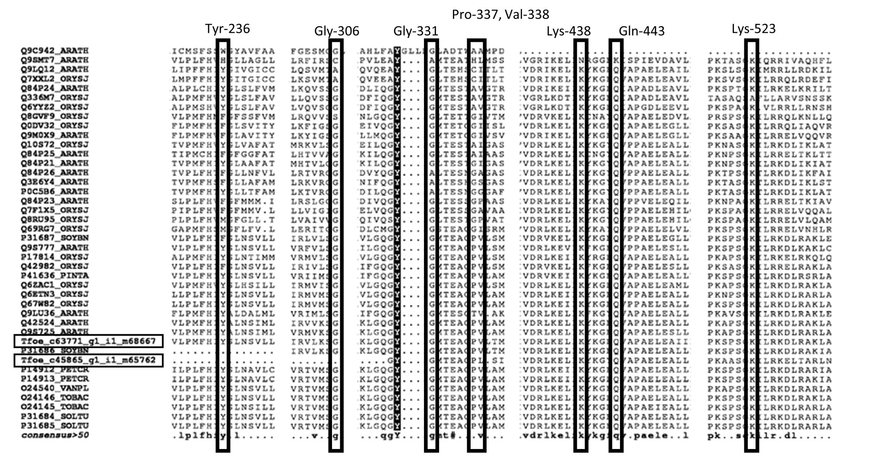
ii. Chalcone synthase
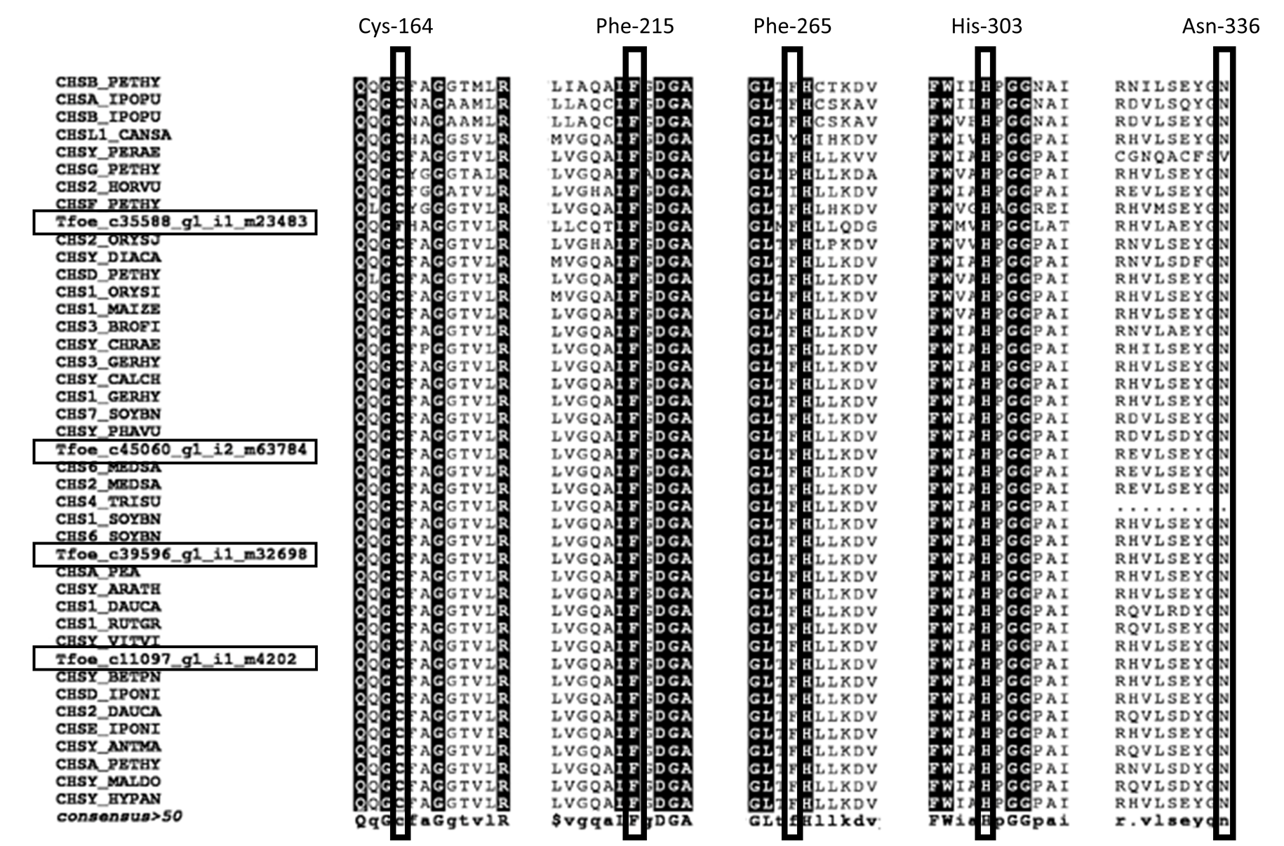
iii. Chalcone flavone isomerase
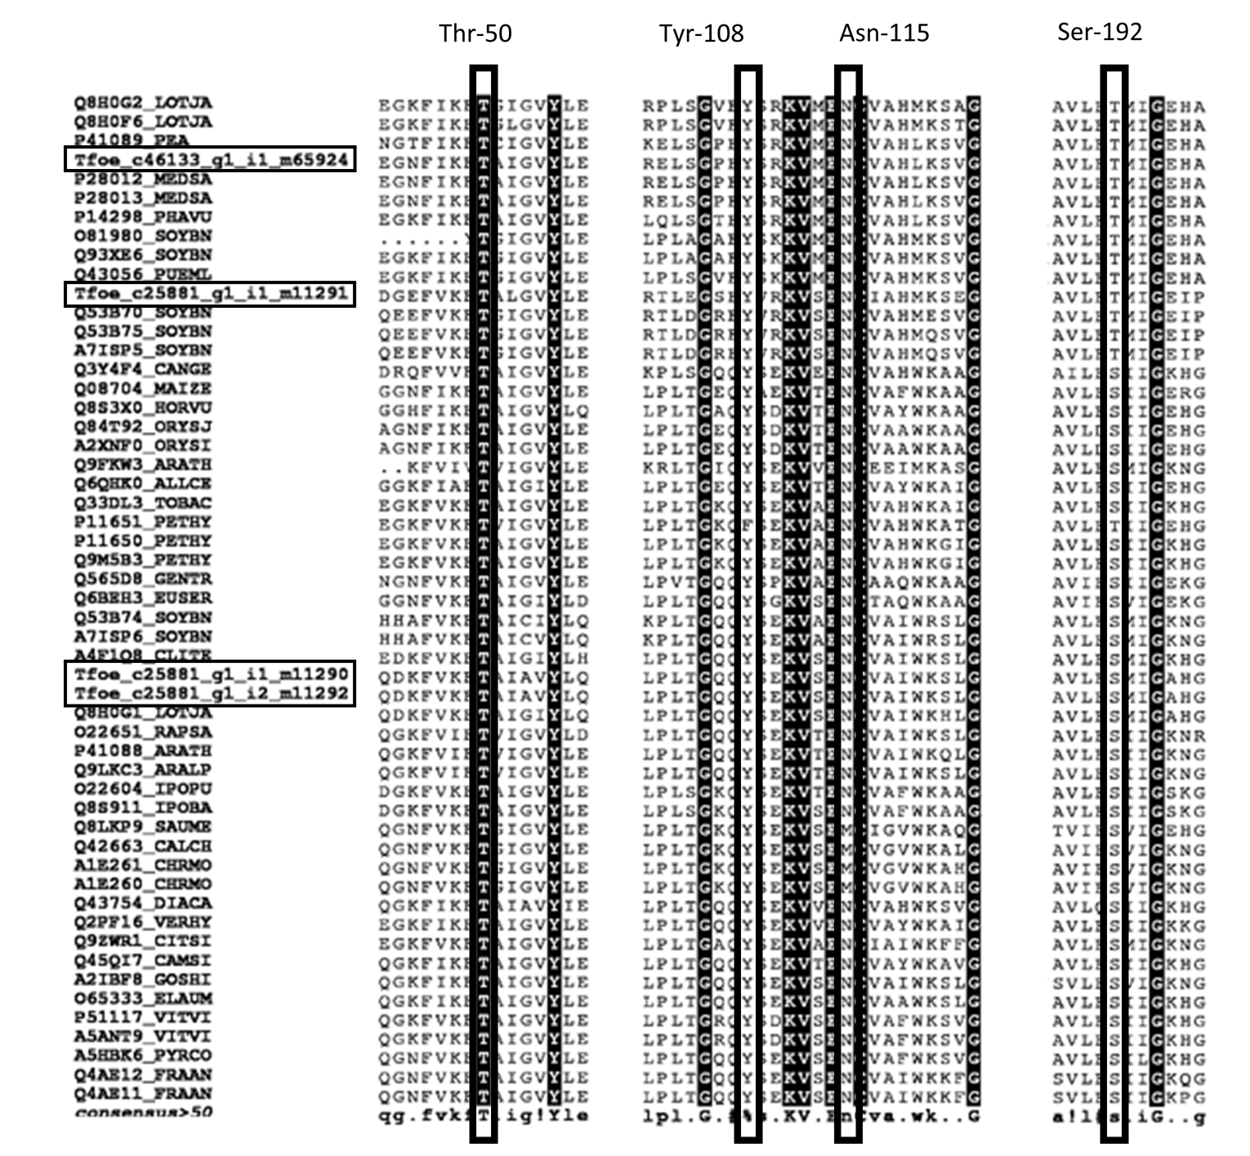
iv. Flavanone 3-hydroxylase / Flavanol synthase
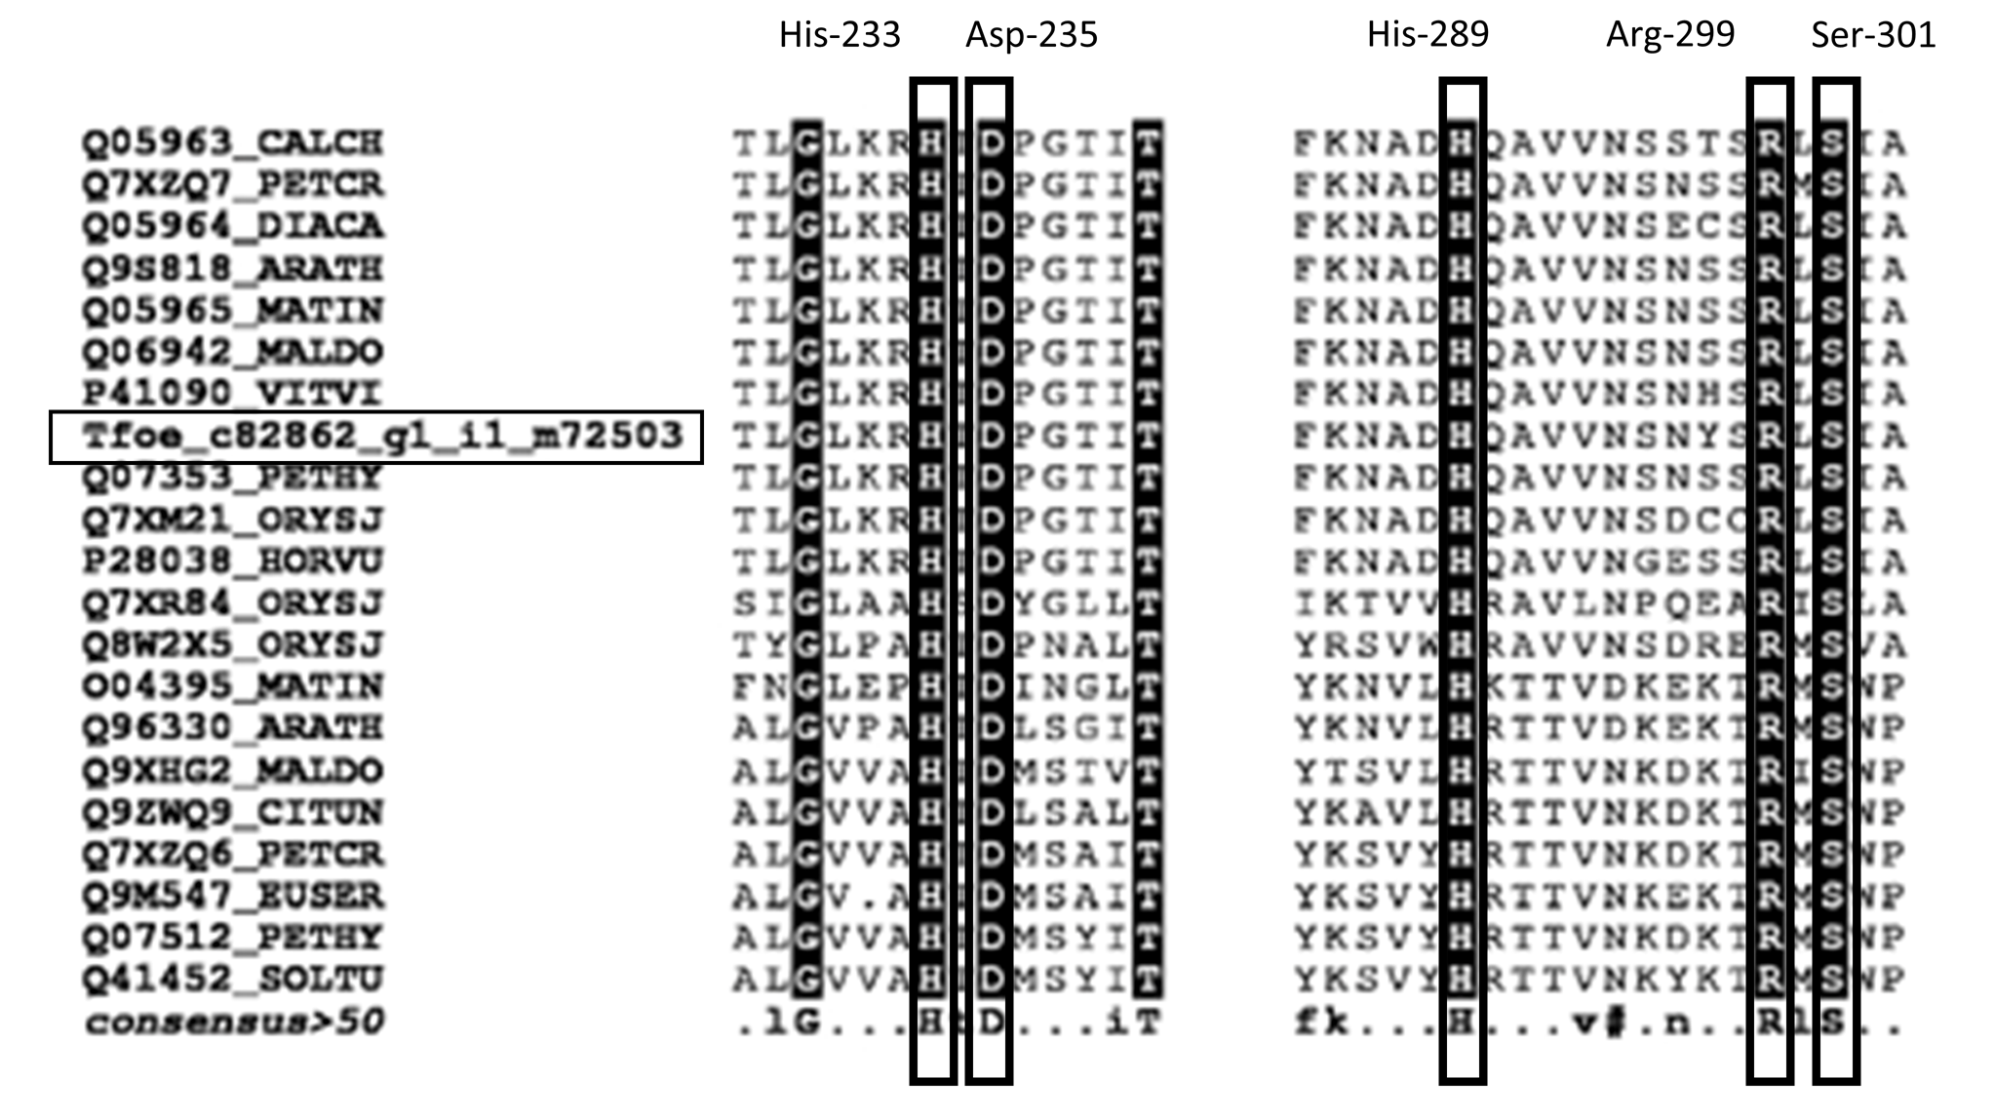

v. Tricin synthase
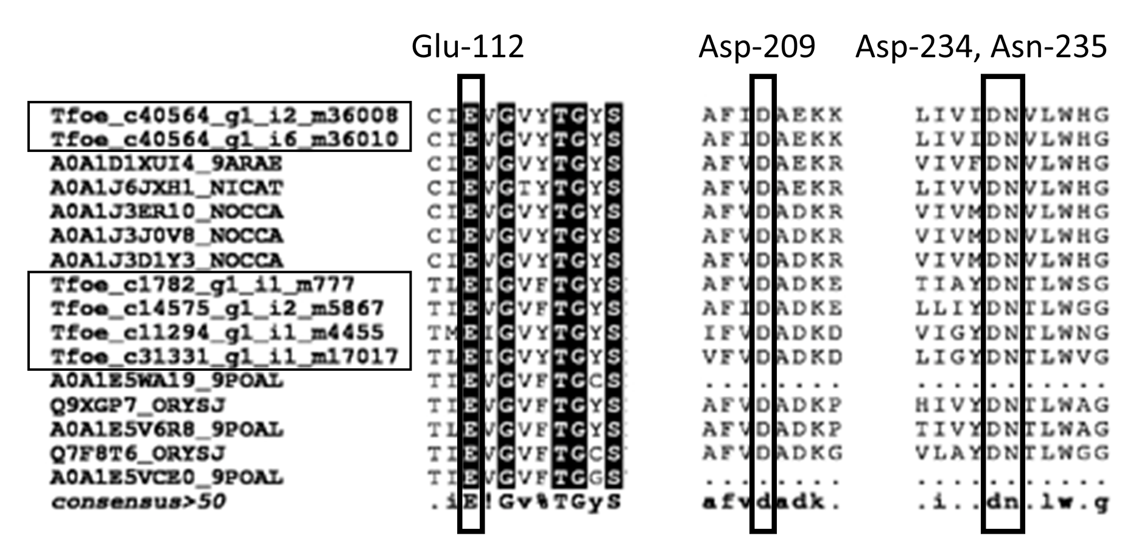
vi. Flavanoid 3'-monooxygenase
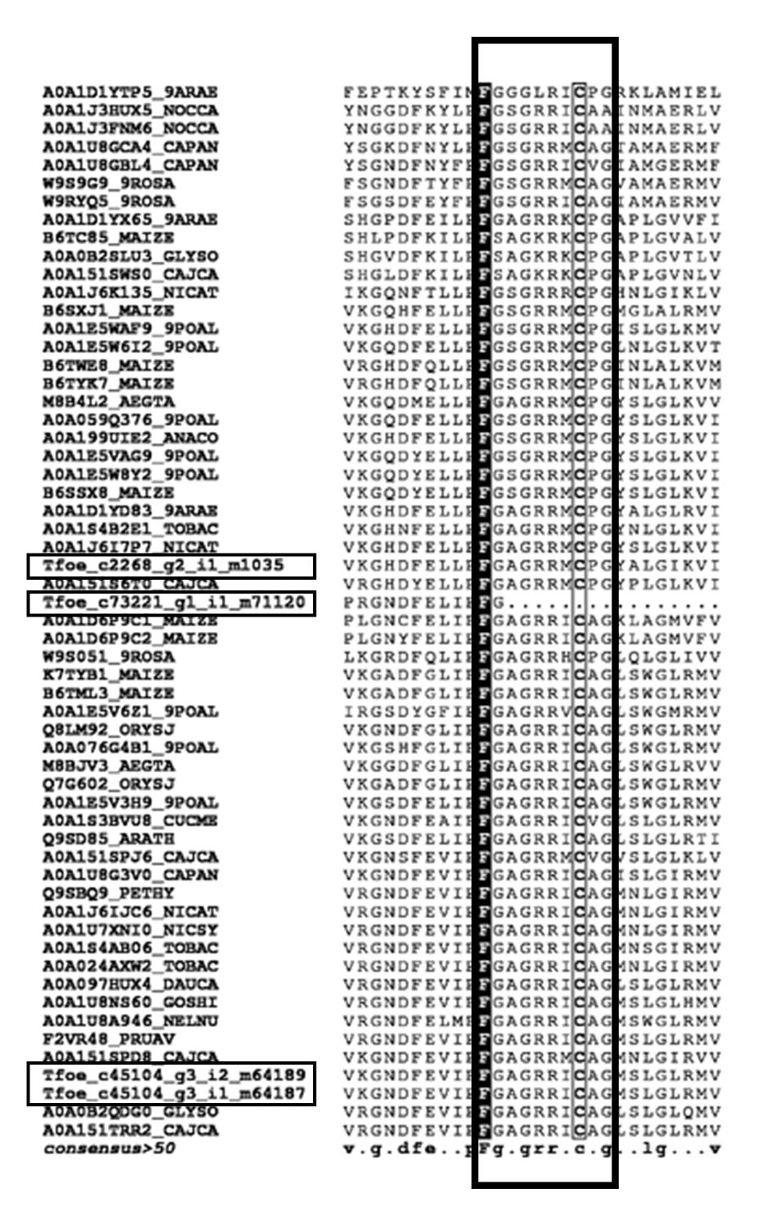

- Phylogenetic tree: Since multiple hits were observed for the enzymes of quercetin biosynthesis pathway, they are marked in the phylogenetic tree. However, those which are co-clustering closely related species have been identified as the best hit and marked in the Supplementary Table 3.
i. Coumarate CoA ligase
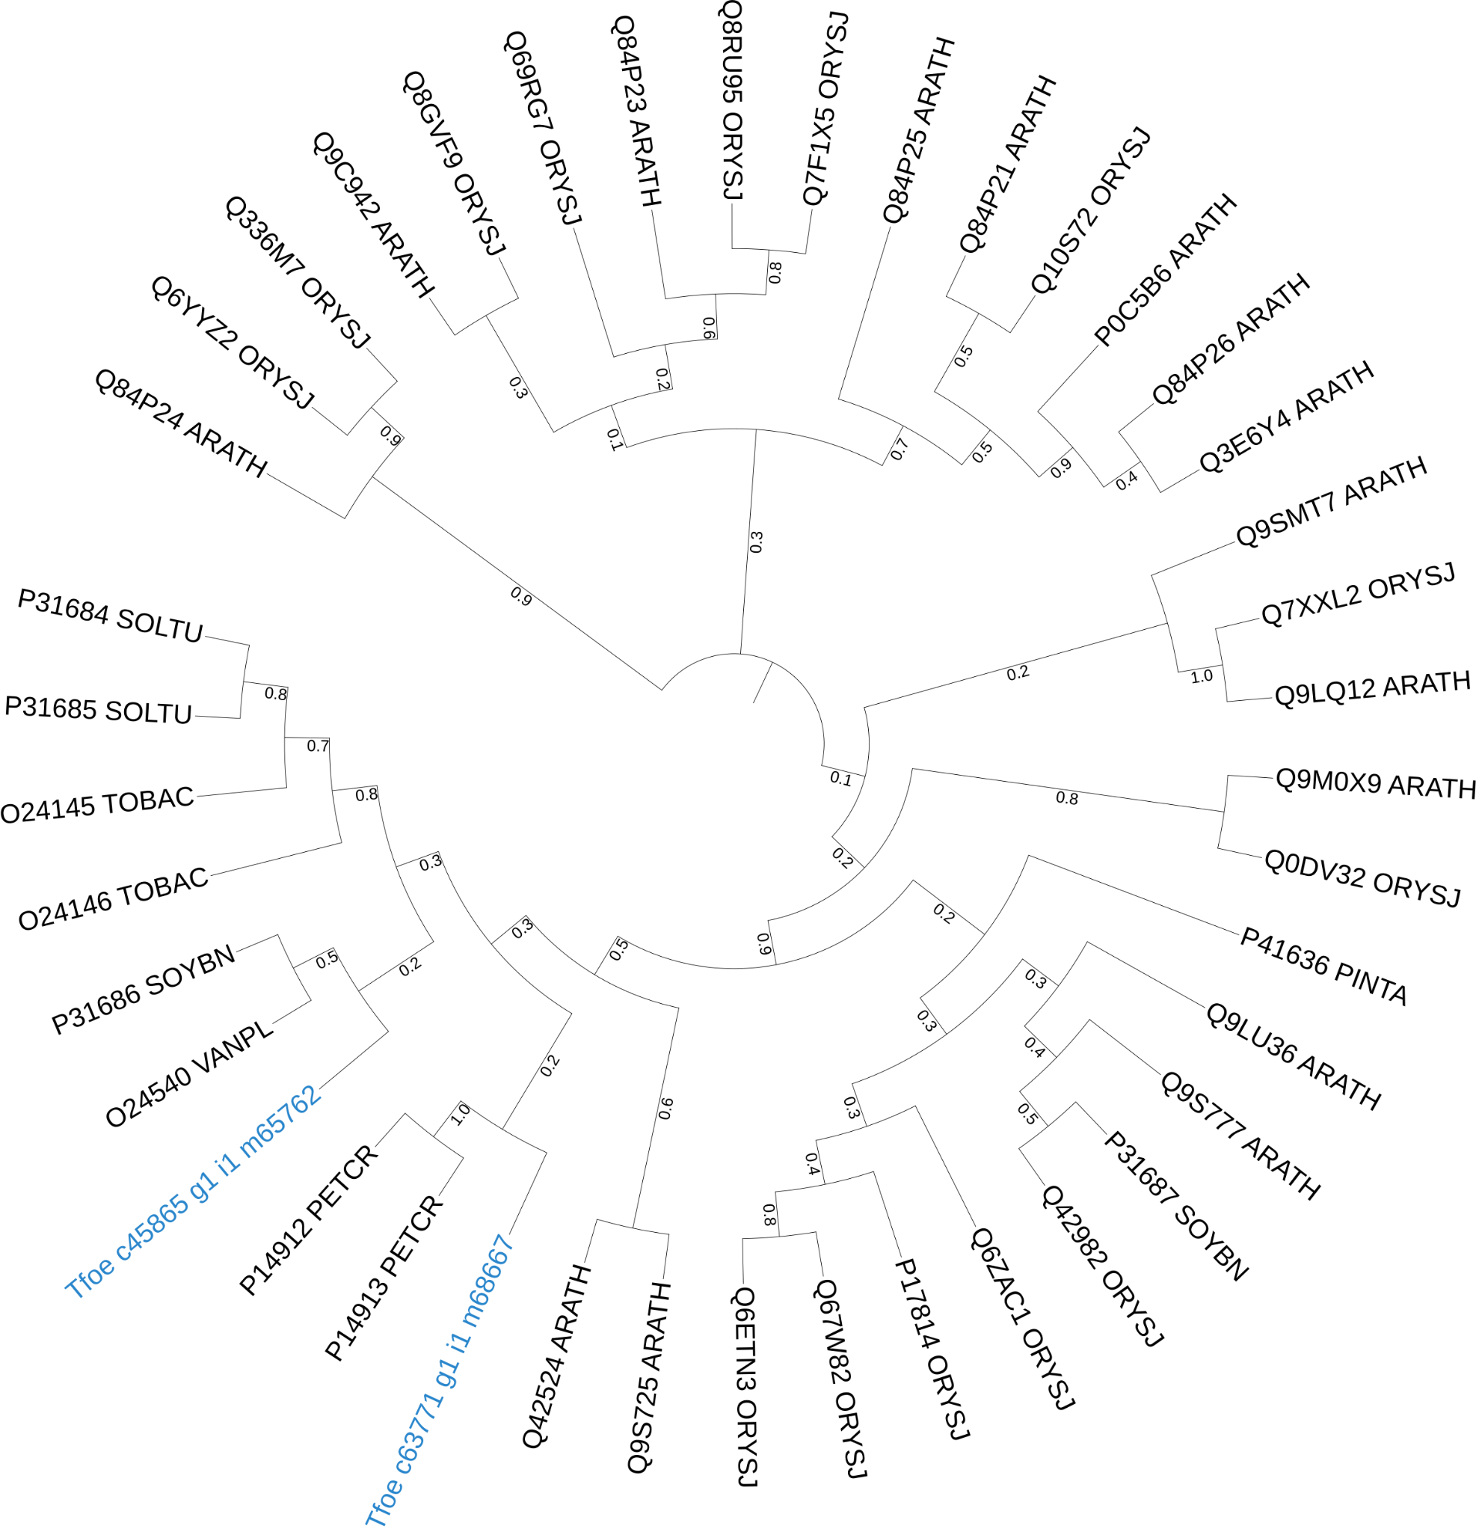
ii. Chalcone synthase
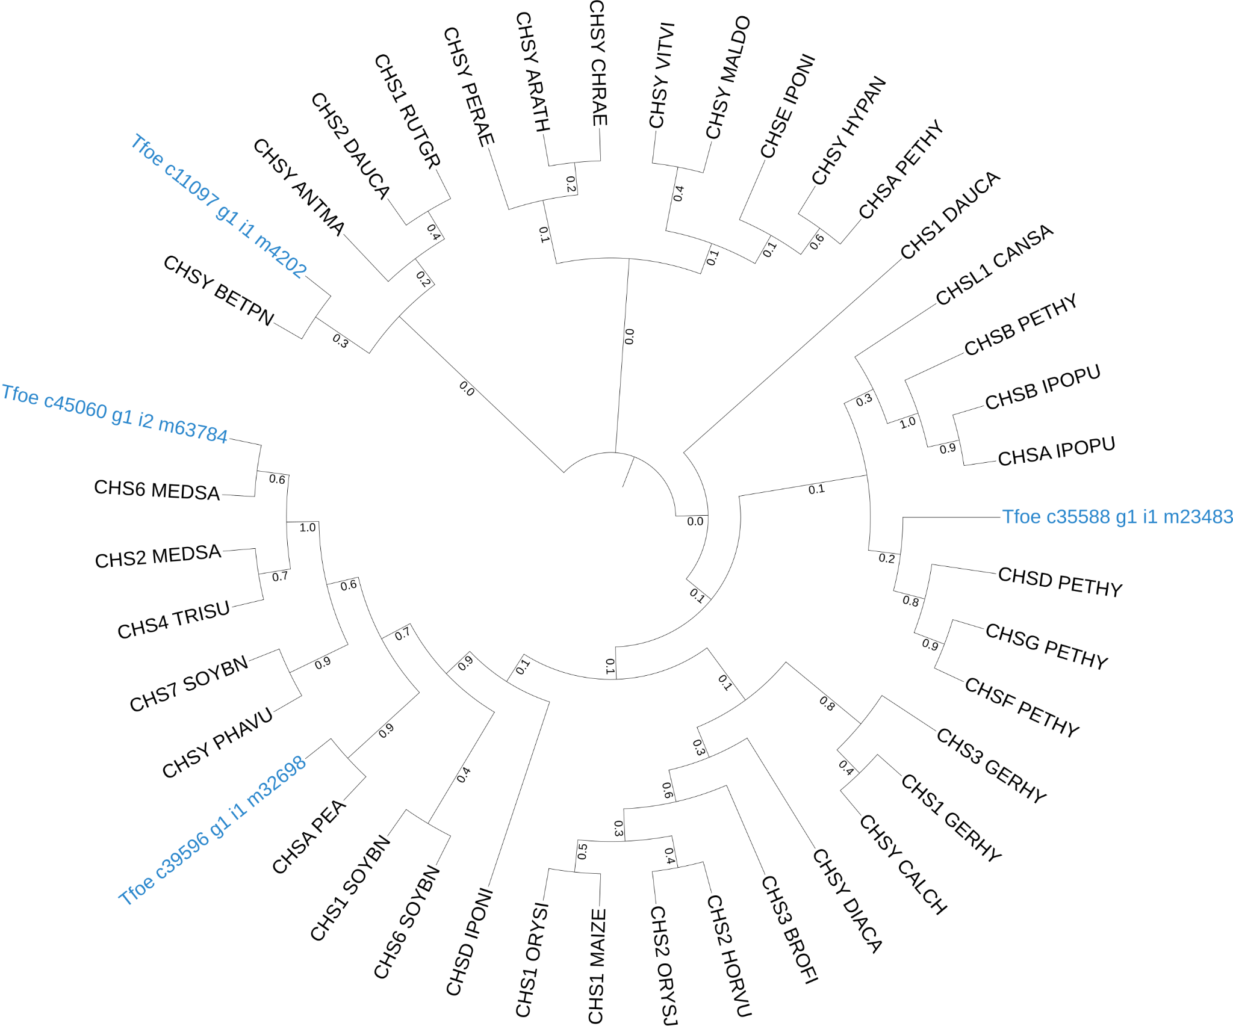

iii. Chalcone flavone isomerase
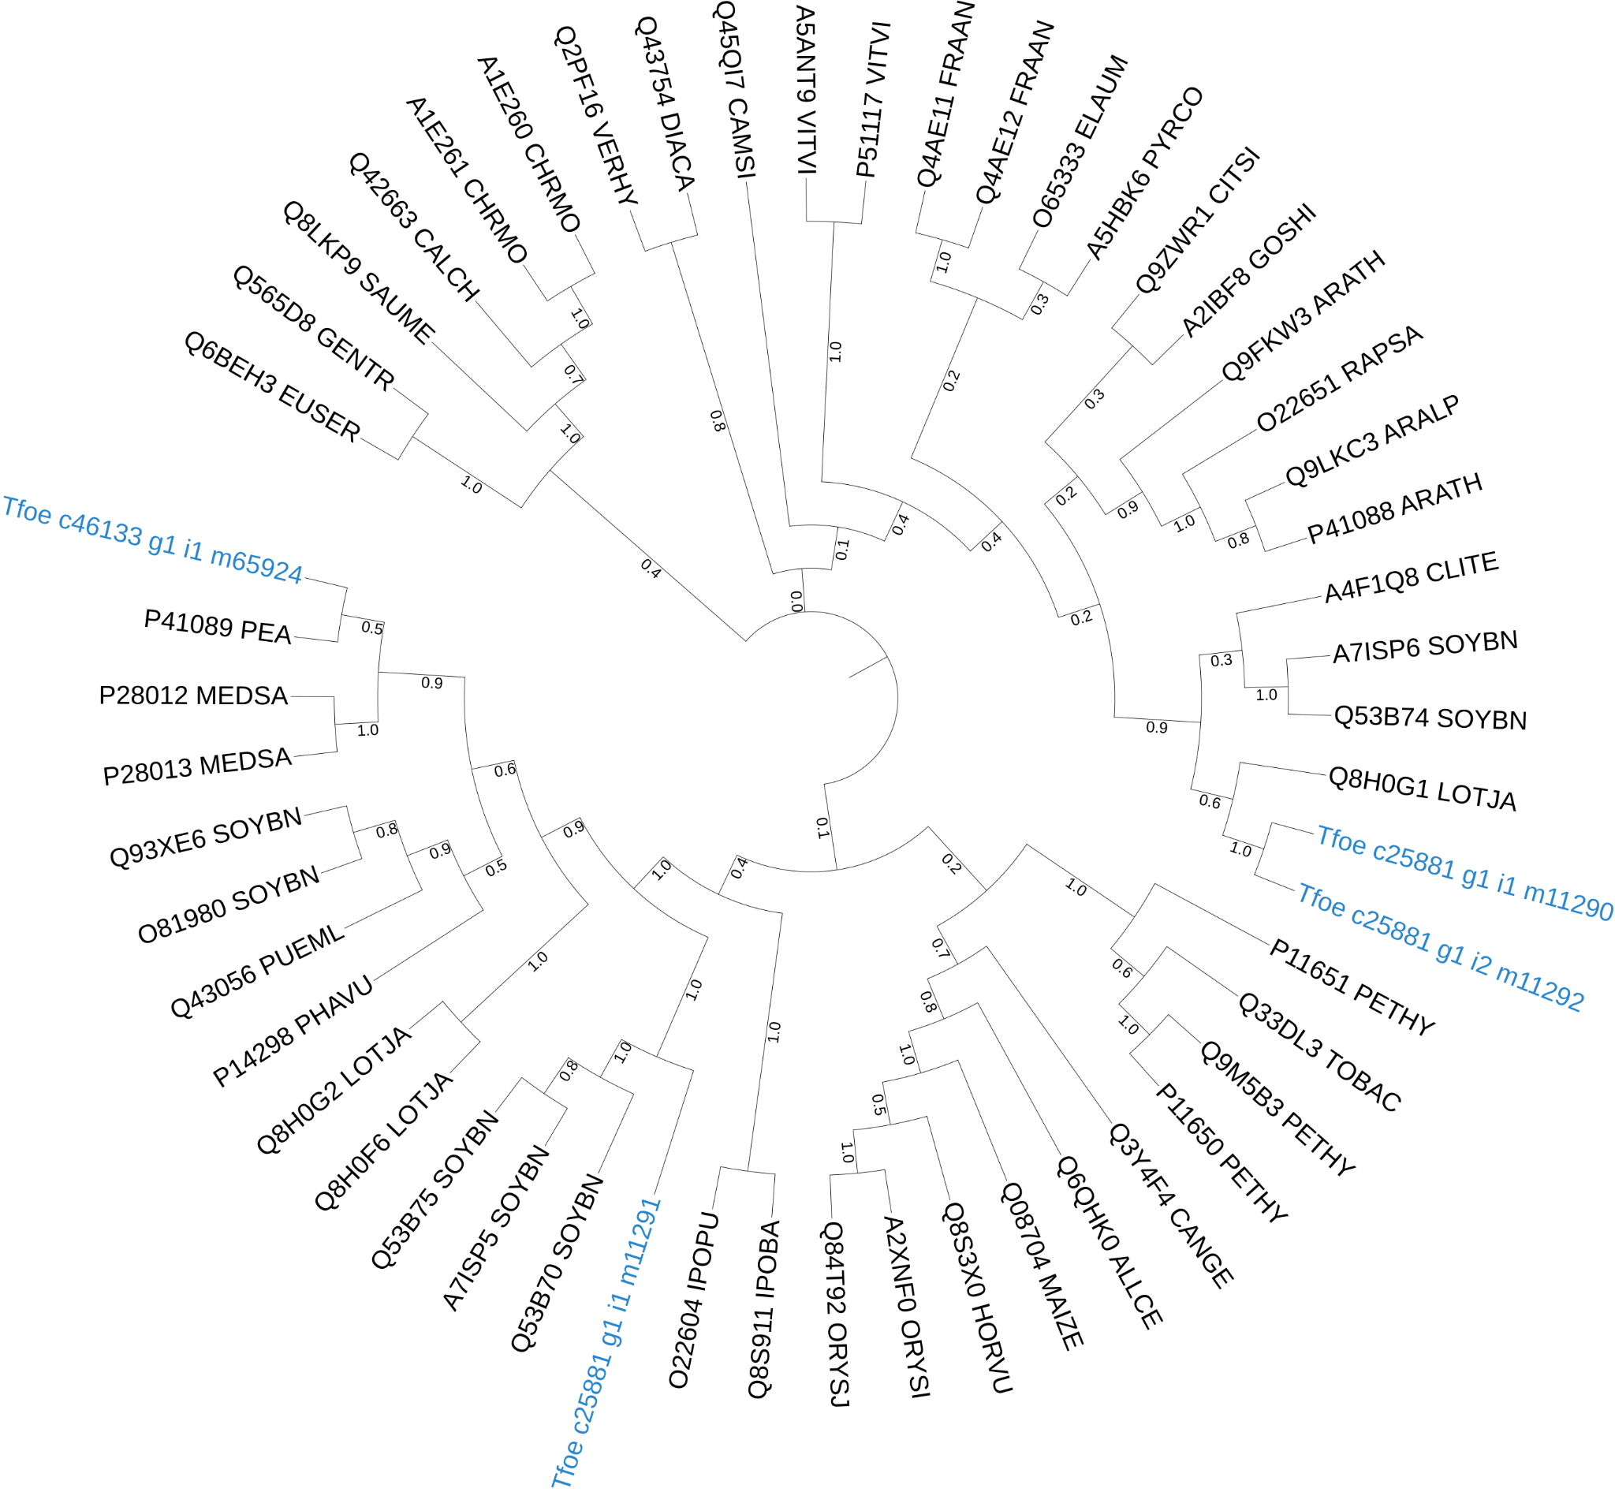
iv. Flavanone 3-hydroxylase / Flavanol synthase

v. Tricin synthase
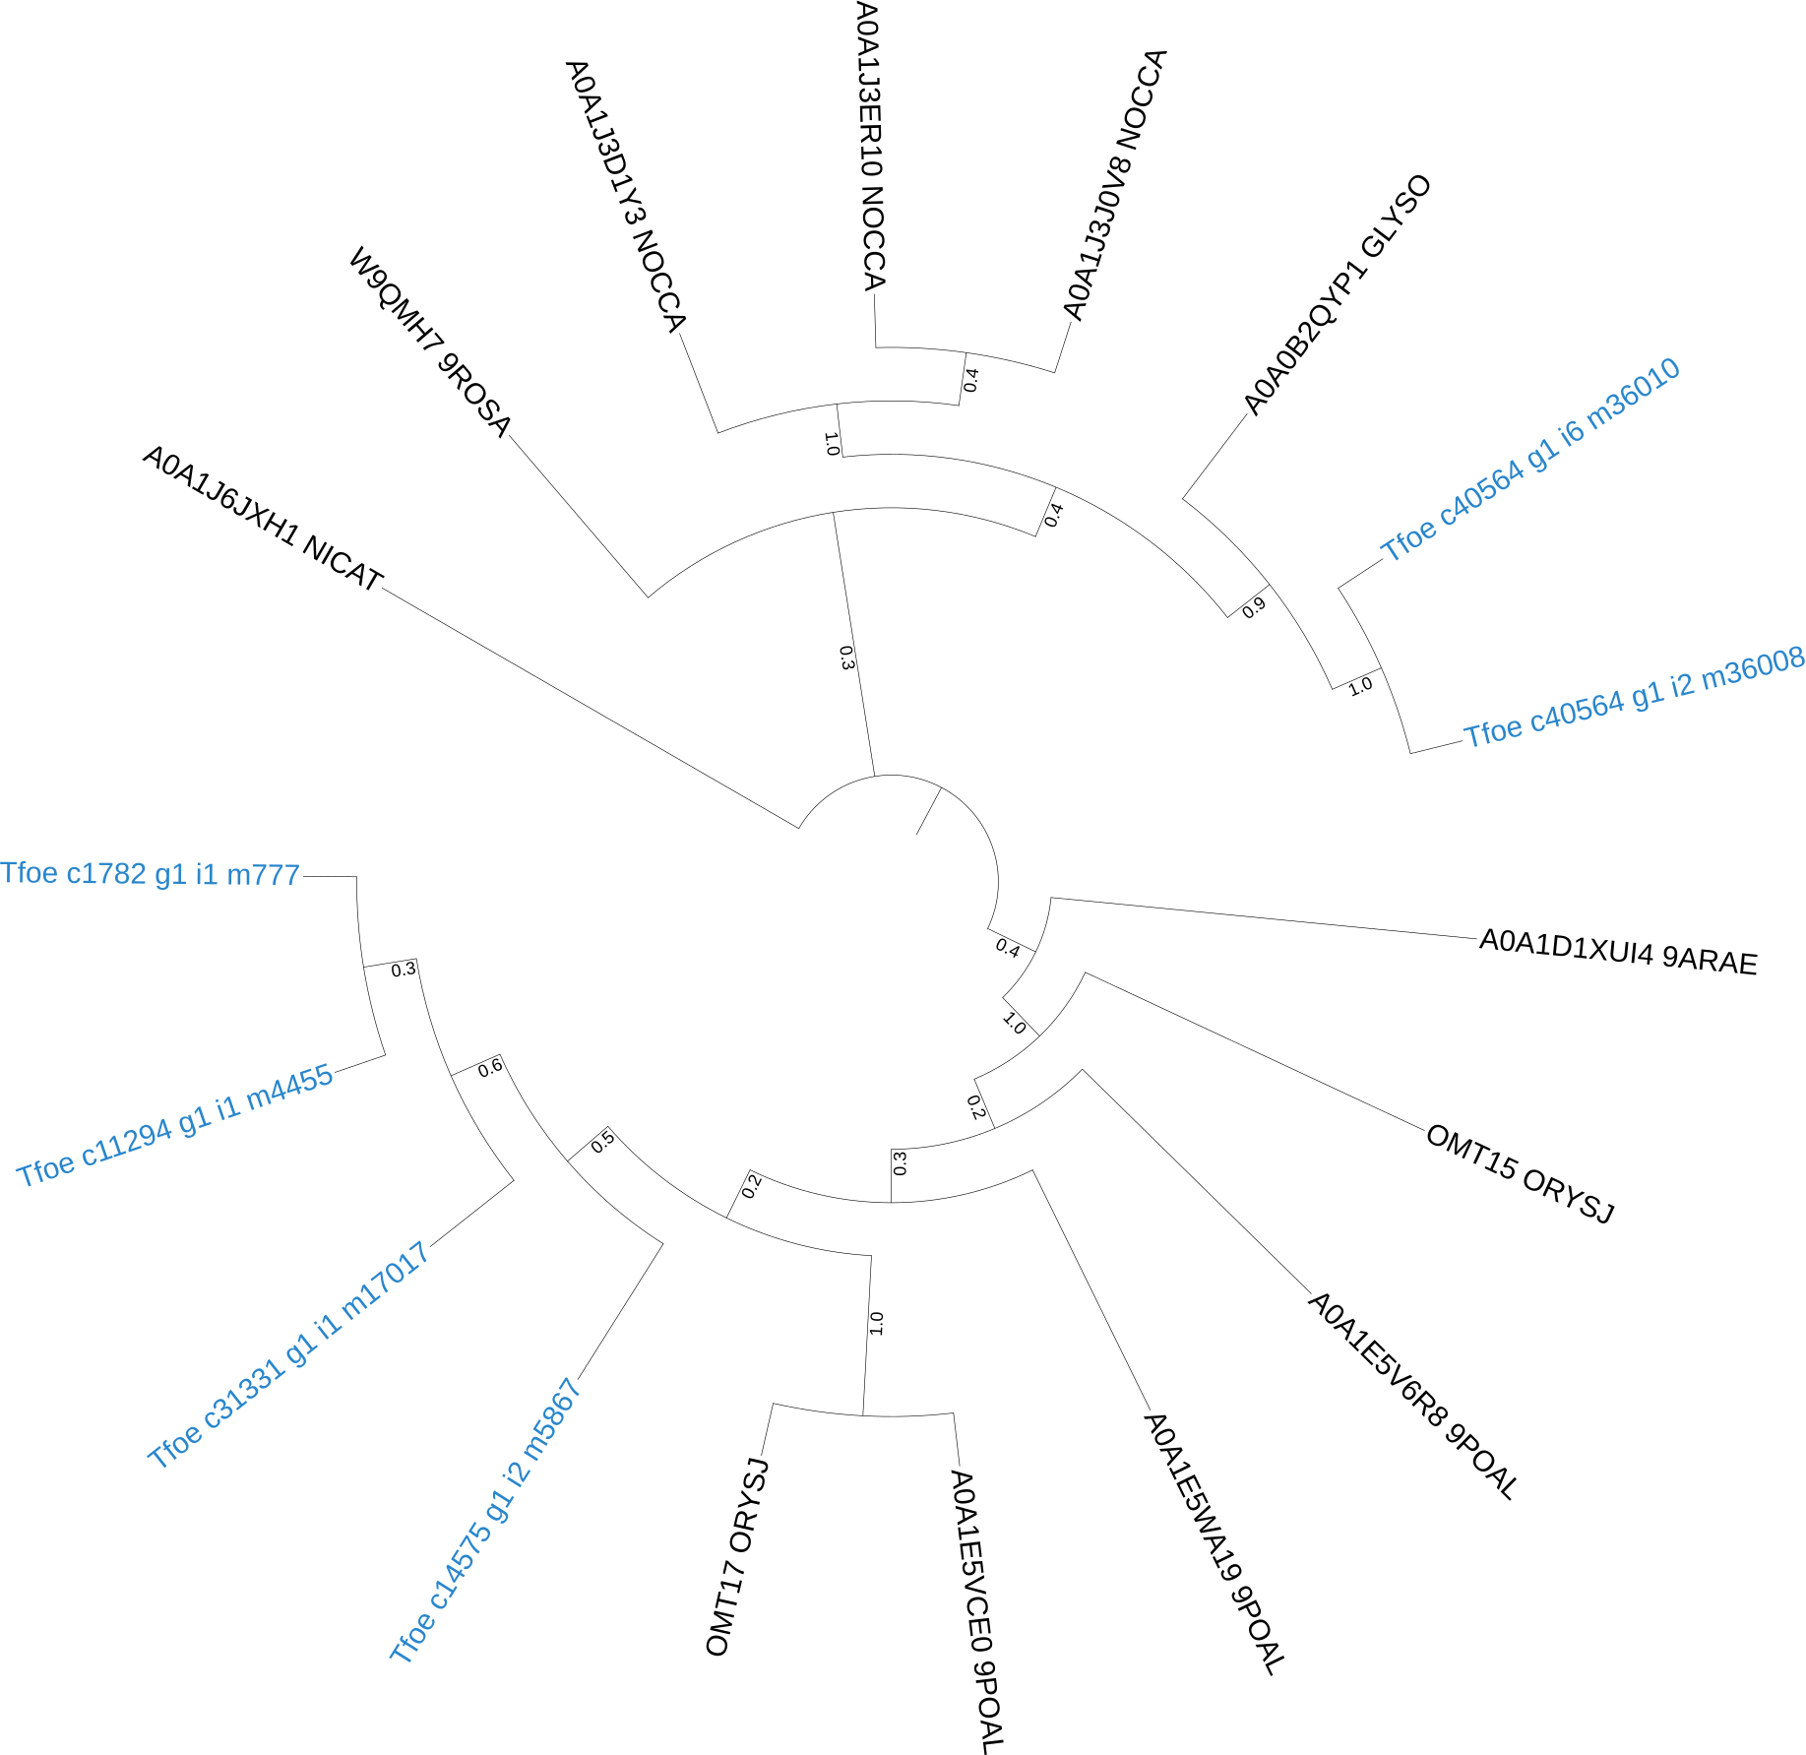

vi. 3'-monooxygenase
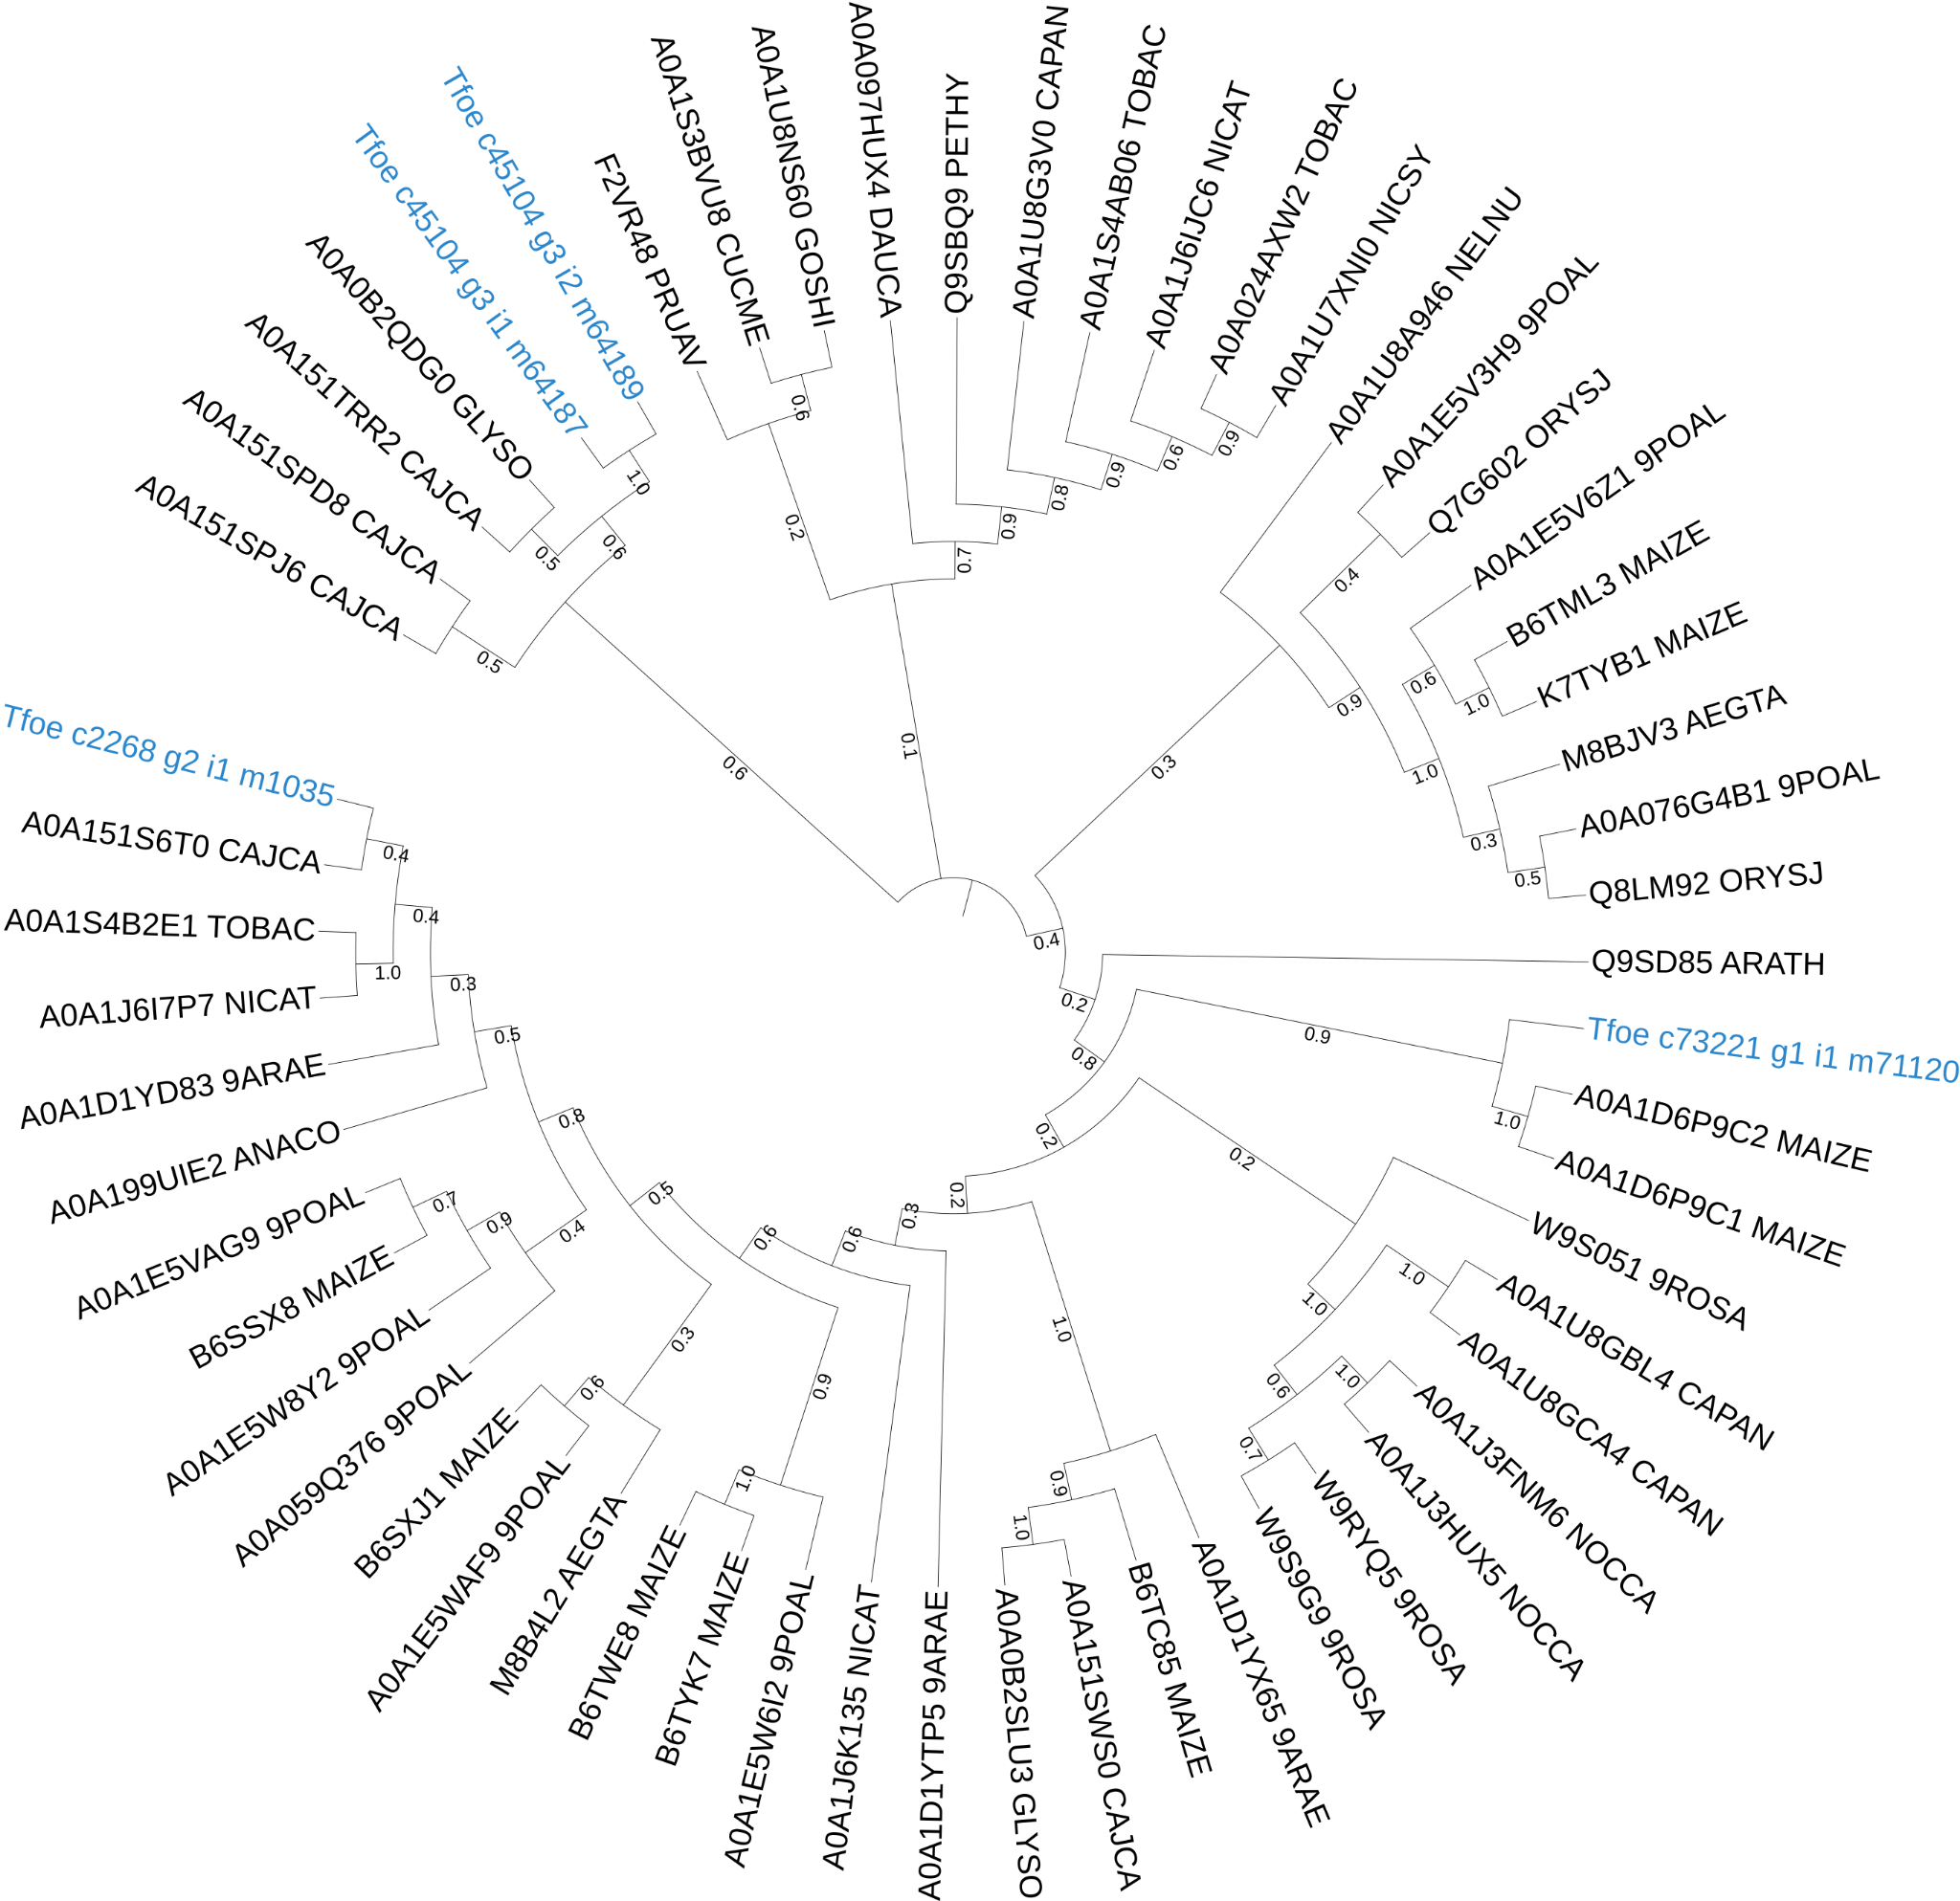

- Vitexin and isovitexin
- Pathway (Adapted from Kerscher, F. and Franz, G, Zeitschrift für Naturforschung C., 1987⁴ and Plant Metabolics Network (PMN), https://pmn.plantcyc.org/PLANT/NEW-IMAGE?type=PATHWAY&object=PWY-6602&detail-level=3, on www.plantcyc.org, Aug 12, 2021¹)
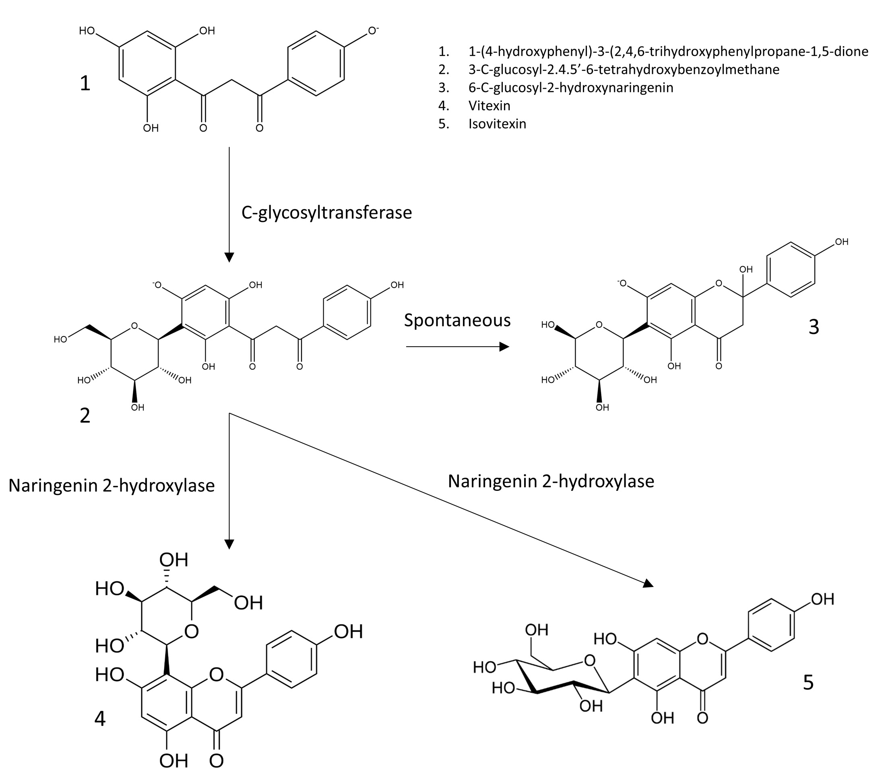
- Phylogenetic tree
i. C-glucosyltransferase
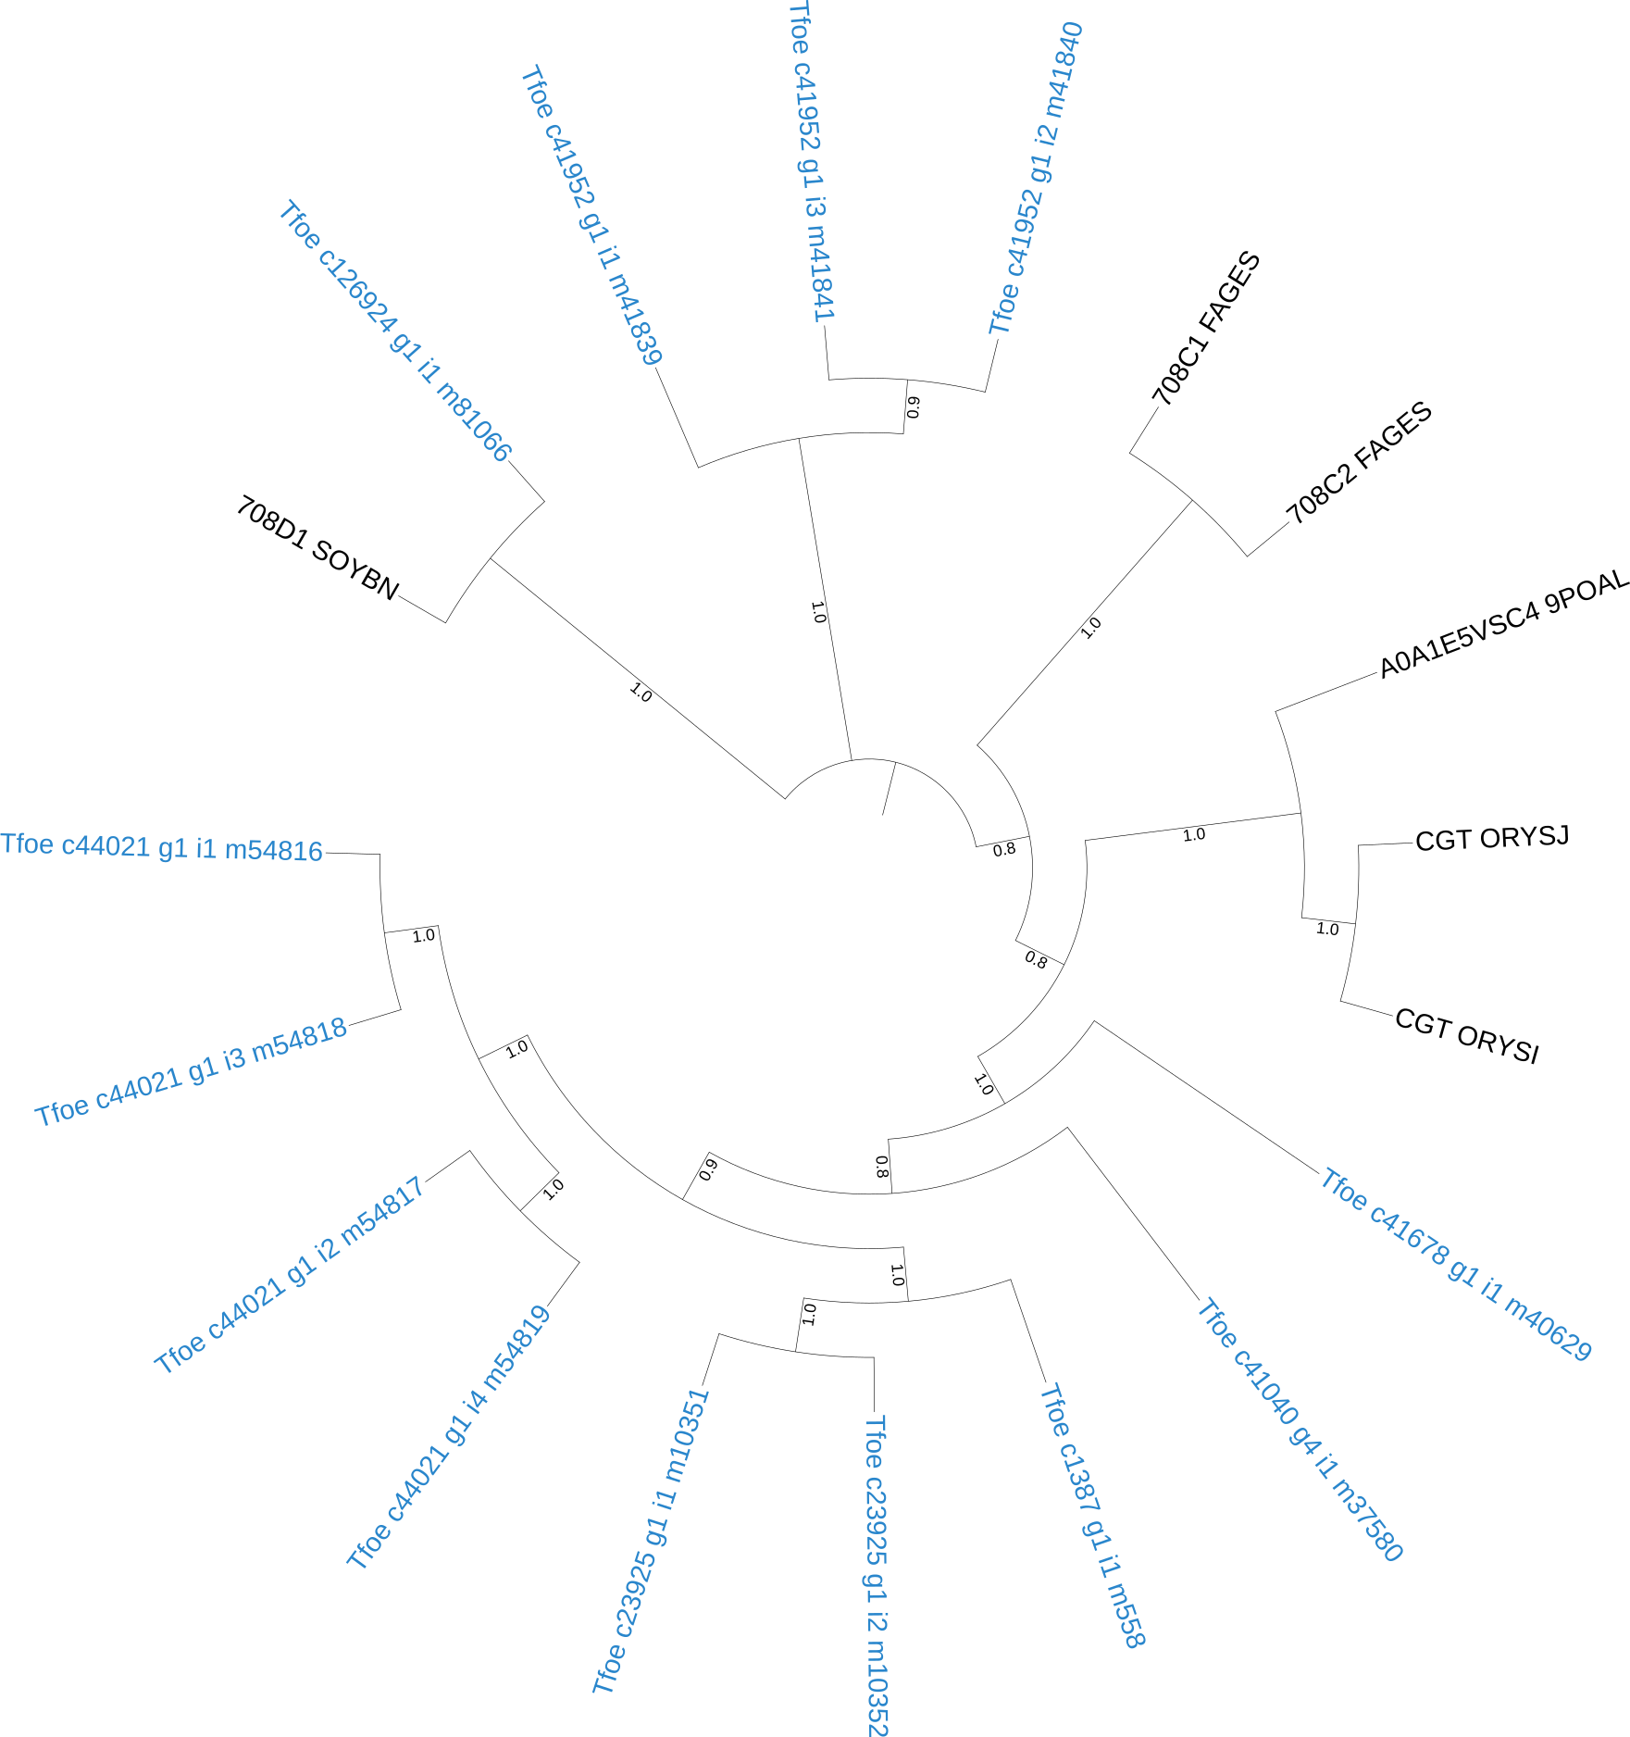
ii. Naringenin 2-hydroxylase
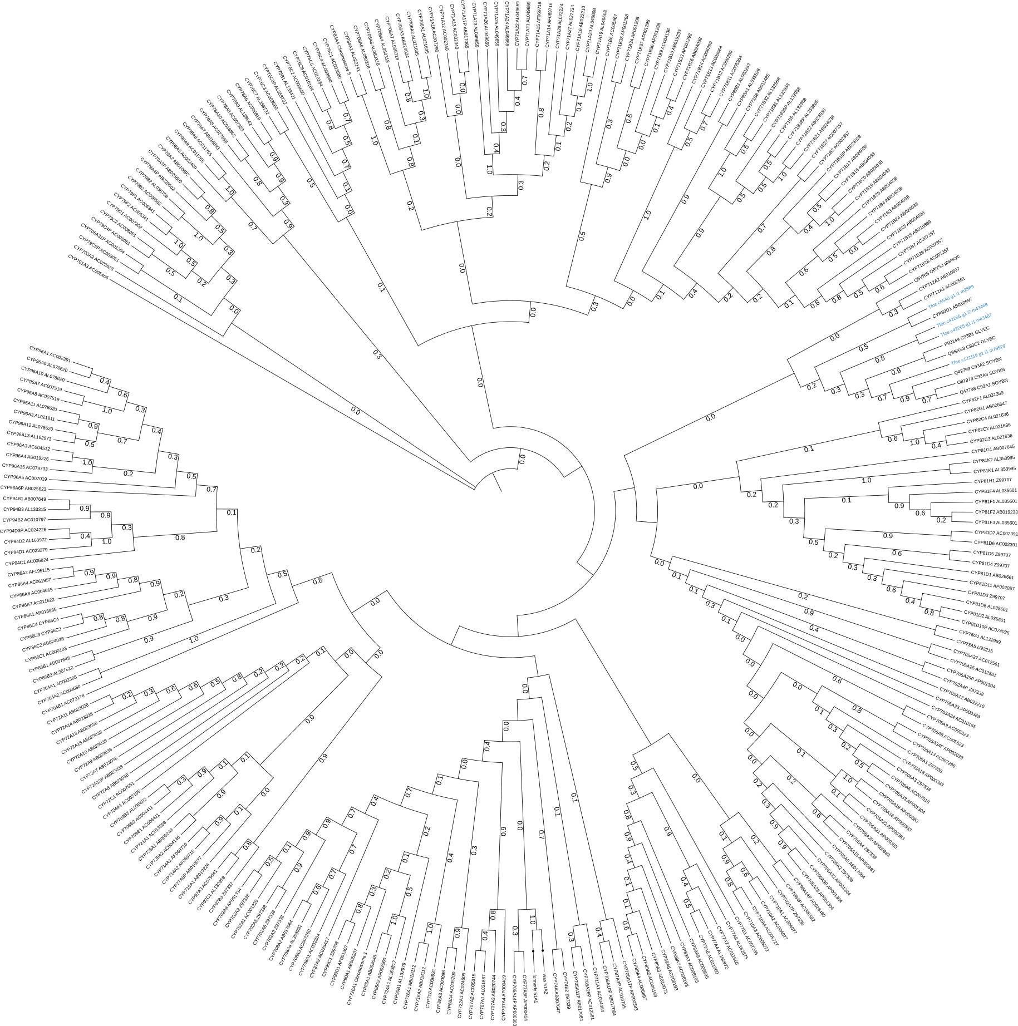

- Rutin
- Pathway (Adapted from Lucci, N. & Mazzafera, P., Canadian Journal of Plant Science, 2009⁵)
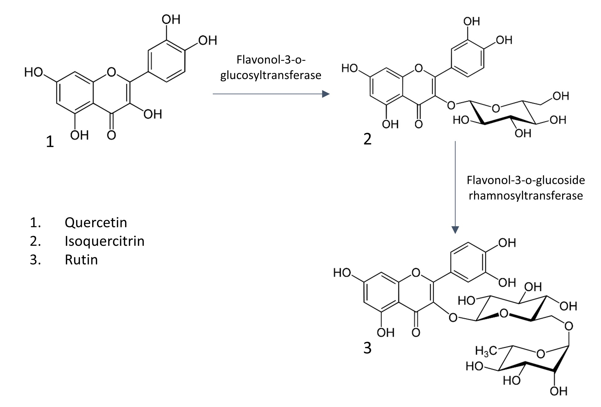

- MSA with FIRs
i. Flavonol-3-o-glucosyltransferase
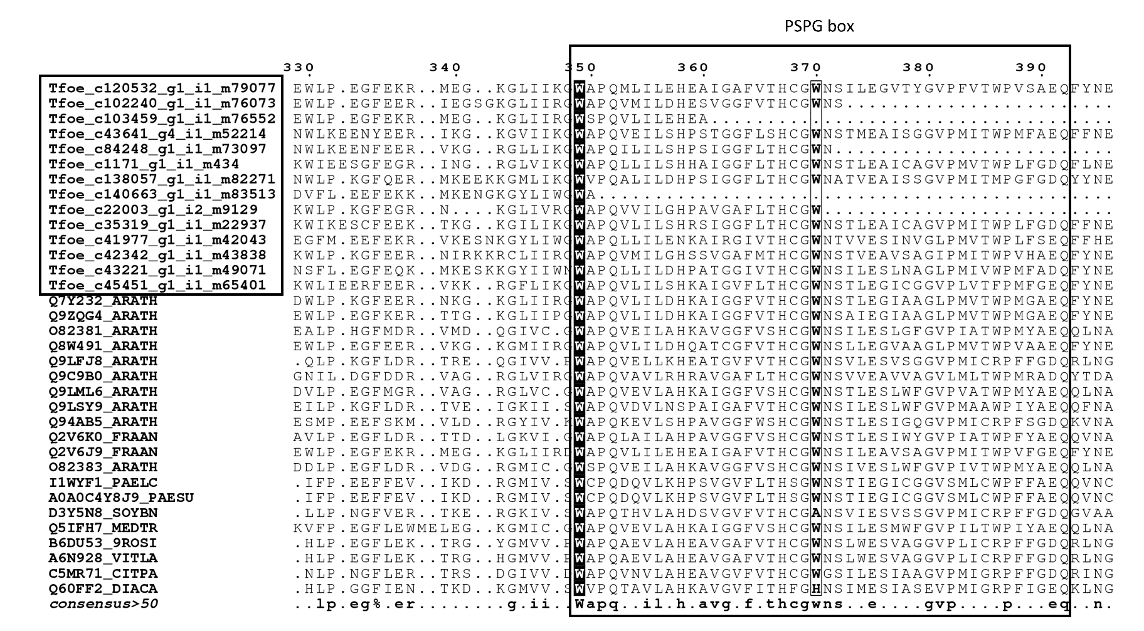
ii. Flavonol-3-o-glucoside rhamnosyltransferase
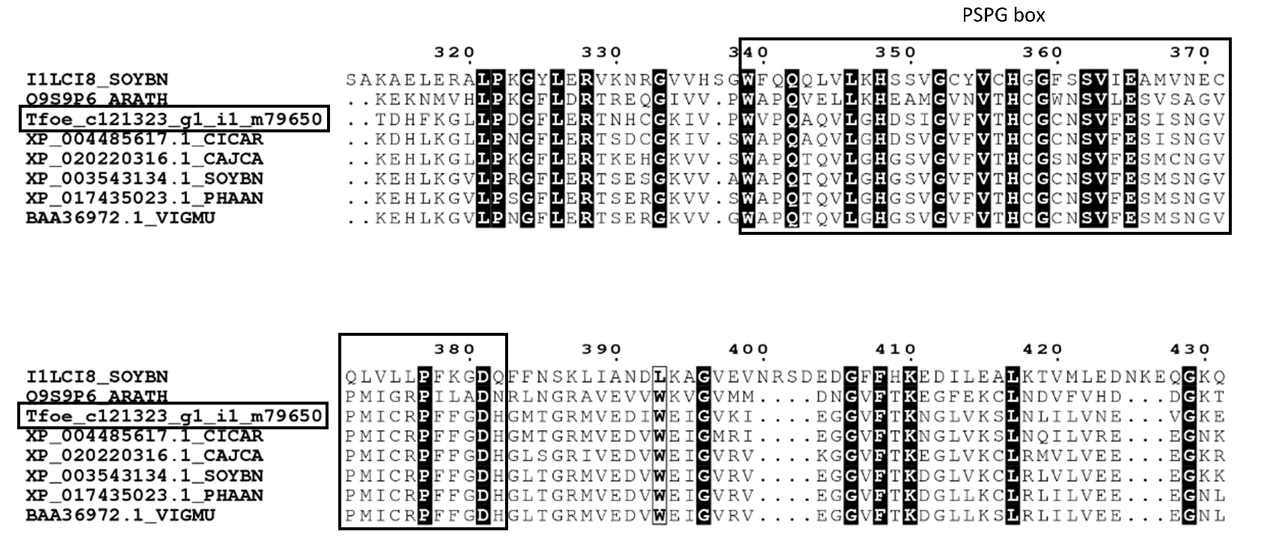

- Phylogenetic tree
i. Flavonol-3-o-glucosyltransferase
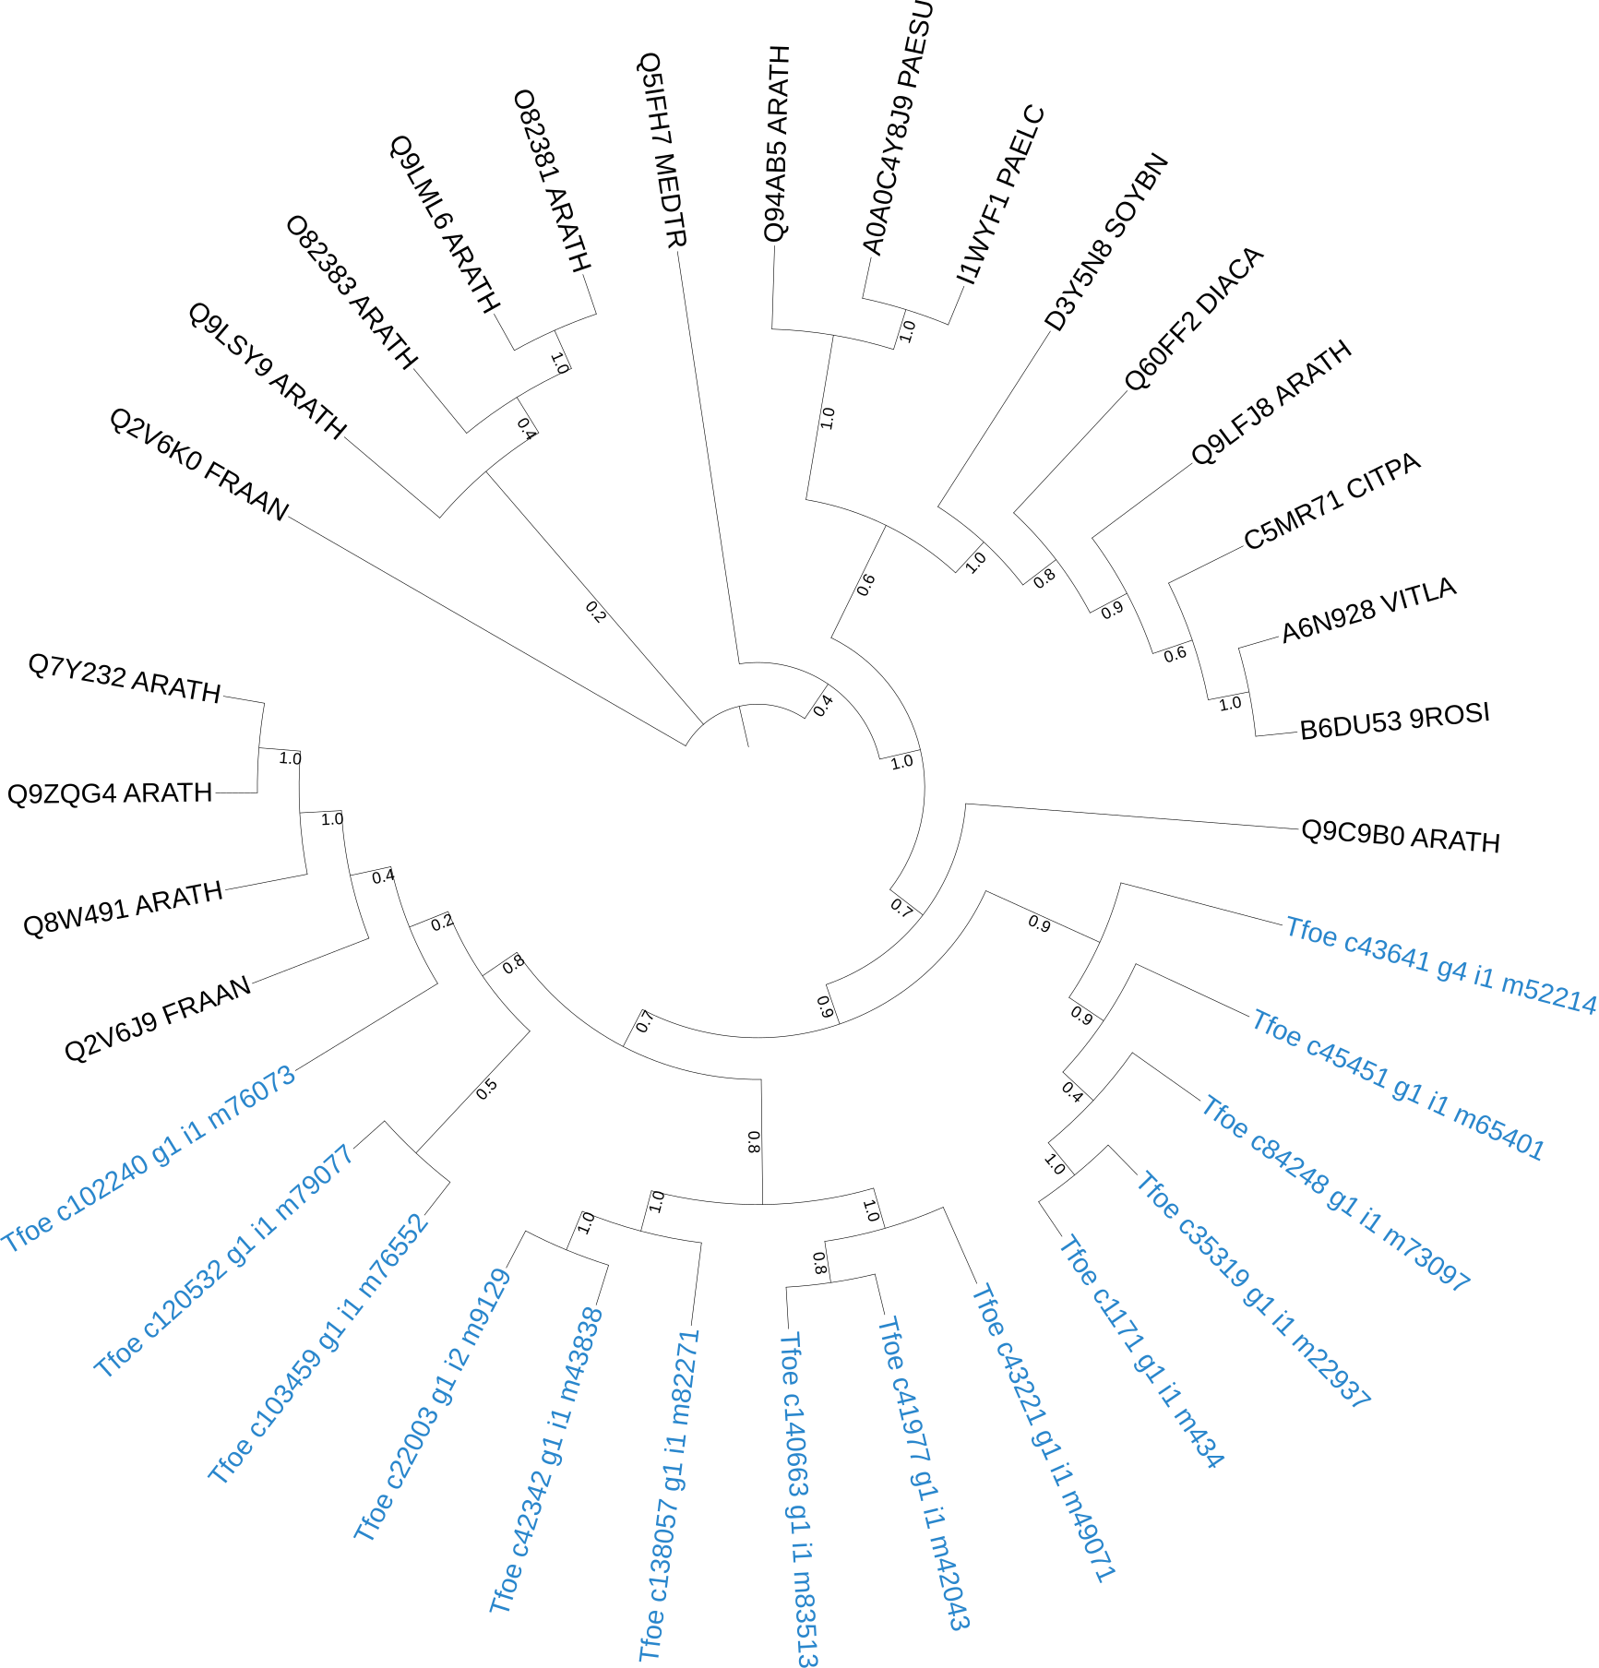
ii. Flavonol-3-o-glucoside rhamnosyltransferase
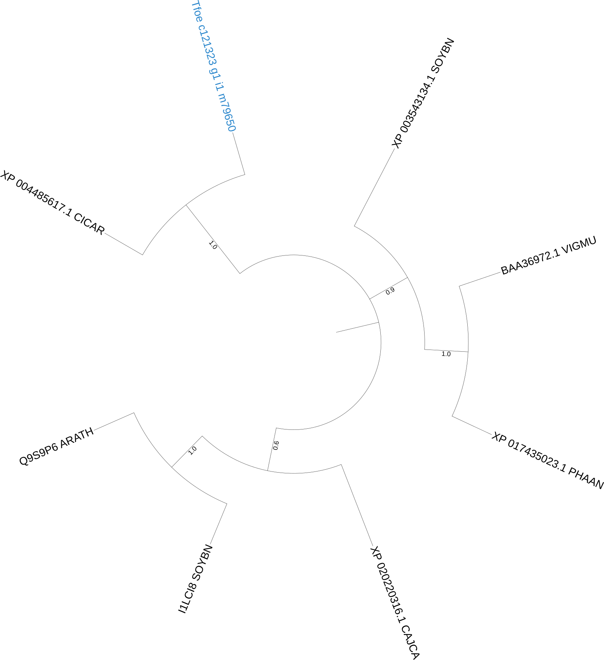
References:
    - Hawkins, C., Ginzburg, D., Zhao, K., Dwyer, W., Xue, B., Xu, A., Rice, S., Cole, B., Paley, S., Karp, P., Rhee, S. Y. Plant Metabolic Network 15: A resource of genome-wide metabolism databases for 126 plants and algae. Journal of Integrative Plant Biology. (2021) doi:10.1111/jipb.13163
    - Ciura, J., Szeliga, M., Grzesik, M. & Tyrka, M. Next-generation sequencing of representational difference analysis products for identification of genes involved in diosgenin biosynthesis in fenugreek (Trigonella foenum-graecum). Planta (2017) doi:10.1007/s00425-017-2657-0.
    - Pasha, S. N. et al. The transcriptome enables the identification of candidate genes behind medicinal value of Drumstick tree (Moringa oleifera). Genomics (2020) doi:10.1016/j.ygeno.2019.04.014.
    - Kerscher, F. & Franz, G. Biosynthesis of Vitexin and Isovitexin: Enzymatic Synthesis of the C-Glucosylflavones Vitexin and Isovitexin with an Enzyme Preparation from Fagopyrum esculentum M. Seedlings. Zeitschrift für Naturforschung C 42, 519–524 (1987).
    - Lucci, N. & Mazzafera, P. Rutin synthase in fava d’anta: purification and influence of stressors. Canadian Journal of Plant Science 89, 895–902 (2009).

